Introduction:
As part of our ongoing commitment to quality and user satisfaction, Laboratory Medicine at UHBW continues to align its practices with ISO 15189:2022, “Medical Laboratories – Requirements for Quality and Competence”. In accordance with Clause 8.4 – Evaluation and continual improvement, and specifically the requirement to seek and evaluate user feedback, we have conducted this annual survey to assess whether our laboratory services are effectively meeting the needs and expectations of our external users.
This survey focuses on GP surgeries across the Bristol and Weston areas, who regularly interact with our services. It follows on from the 2023 user survey, which was the first since the merging of UHBW Laboratory Medicine services. Building on that foundation, the 2025 survey reflects our ongoing efforts to adapt, evolve, and deliver a responsive, high-quality service to our users in a rapidly changing healthcare environment.
We recognise the critical role GP practices play in patient care, and this survey offers an important opportunity to identify what we’re doing well and where improvements are needed—directly from the perspectives of our users.

Objectives:
- To gather actionable feedback from GP surgeries on their experience with the Laboratory Medicine service, focusing on communication, turnaround times, sample logistics, reporting quality, and accessibility.
- To identify both strengths and areas for improvement in our service delivery-highlighting best practices that can be reinforced and shared across all service points.
- To ensure user perspectives are embedded in our service development and quality improvement strategies, with the goal of enhancing both user satisfaction and patient care outcomes.
- To fulfil the ISO 15189:2022 requirements on user feedback and continuous improvement, reinforcing our commitment to quality and patient-centred service delivery.
- To use survey insights as a catalyst for process improvements, enhanced training, better communication, and system-level changes where appropriate.

Response to the survey
For this survey, the focus group consisted of external users of the laboratory service based at GP surgeries across the Bristol and Weston areas. The survey was designed by the Quality Management Team within Laboratory Medicine to gather user feedback on the service, particularly in the context of the newly implemented analysers as part of a renewed Managed Services Contract, and the ongoing quality improvement initiatives. The survey was open for responses between 09th June 2025 and 19th September 2025, conducted via the SurveyMonkey platform. The survey opening timeframe was significantly extended this year to allow for a sufficient number of respondents to feedback to ensure a wide variety of results and opinions were received.
Respondents’ roles:
Role | Number of responses
GP | 14
Nurse | 6
Practice Manager | 3
Nursing/healthcare assistance | 3
GP Trainee | 0
Admin | 0
Other (please specify) | 3
Totals | 29

Survey Questions
The following questions for this survey were designed by the laboratory Medicine Quality Team.
Q1: What is your current job role?
Q2:What GP Surgery or community healthcare provider is your role predominantly based at?
(demographic questions were included to better isolate issues that maybe role or site specific)
Q3: The overall service meets my needs.
Q4: I know where to find the Laboratory medicine user guides (used at the Bristol Royal Infirmary) or the Pathology User Manual (used at Weston general Hospital).
Q5: Laboratory staff are polite, knowledgeable and easy to contact
Q6: The test repertoire meets the needs of my service and patients.
Q7: Results are clear, concise, easy to understand and reported within an appropriate timeframe.
Q8: I am able to access appropriate clinical advice about test results when required.
(The satisfaction of the above statements were graded from Strongly agree, Agree, Neutral, Disagree, and Strongly disagree. We interpreted Strongly agree, Agree, or Neutral as equal to satisfied. Disagree or Strongly disagree as dissatisfied)
Q9: How can we improve our pathology service to better meet your needs? (e.g. faster turnaround, clearer reports, better communication — mention department or assay if relevant. Leave contact info if you’d like a response.)
Q10: What part of our pathology service do you feel has a positive impact on your practice? (We’d like to recognise and build on what’s working well.)
(Two open question was included to allow staff to express specific comments they wished to highlight)
The survey was built, distributed and collected on Survey Monkey platform.
We distributed the survey link via email to all Practice Managers and GPs. However, many of the initial responses we received were from outdated email addresses. The survey was originally open for four weeks, but due to a high number of staff being on annual leave across practices and the limited relevance of early responses, we only received around 10-12 valid responses during that period.
As a result, the survey was extended. While the response rate gradually increased over the following months, it stopped at 17-still short of the minimum target of 25 responses. A follow-up email was sent on 9th September 2025, which significantly boosted engagement. By 19th September 2025, the total number of responses had increased to 29.
The laboratory's target for user satisfaction is to achieve a satisfactory response rate of over 90% for each statement in the survey. A satisfactory response is defined as “Strongly Agree,” “Agree,” or “Neutral.” Any results falling below this threshold will be subject to further review and investigation to determine what actions are needed to improve the relevant aspects of the service.

Results
The following graphs illustrate the results of the response for each of the questions:
Q1: What is your current job role?
Results: answered 29, skipped 0
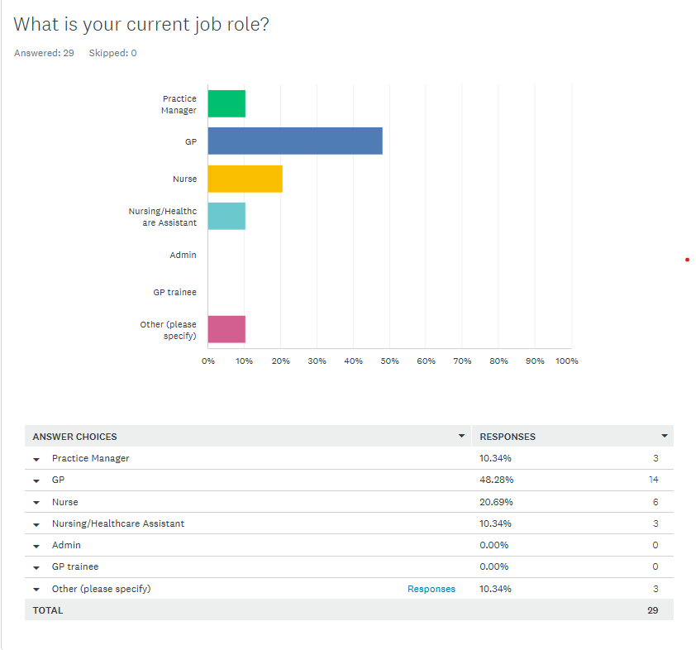
Other (Please specify) responses included:
- Paramedic in Primary care
- PCN Manager and SB Locality Non Clinical Lead
- Managing partner

Q2: Which GP surgery or community healthcare provider is your role predominantly based at?
Results: answered 29, skipped 0
GP Surgery | Number of Responses
Charlotte Keel Medical Practice | 6
Bridge Medical Practice | 3
Fallodon Way (Henleaze) | 1
Pier Health PCN | 1
Students' Health Service | 2
East Trees Surgery | 3
Lawrence Hill Health Centre | 1
Lodgeside surgery | 1
Whiteladies Medical Group | 1
Bristol St George | 1
Air Balloon Surgery | 2
Shirehampton | 1
BVM | 1
Wellspring surgery | 1
Gloucester Road Medical Centre | 1
Tudor Lodge Surgery | 1
MVMG - sites across BNSSG | 1
Birchwood | 1
Totals | 29

Comments: Please note that not all GP surgeries served by Laboratory Medicine provided a response. Consequently, the survey findings may not fully represent the views of all GP surgeries using our service.

Q3: The overall Pathology service meets my needs.
Result: answered 29,skipped 0
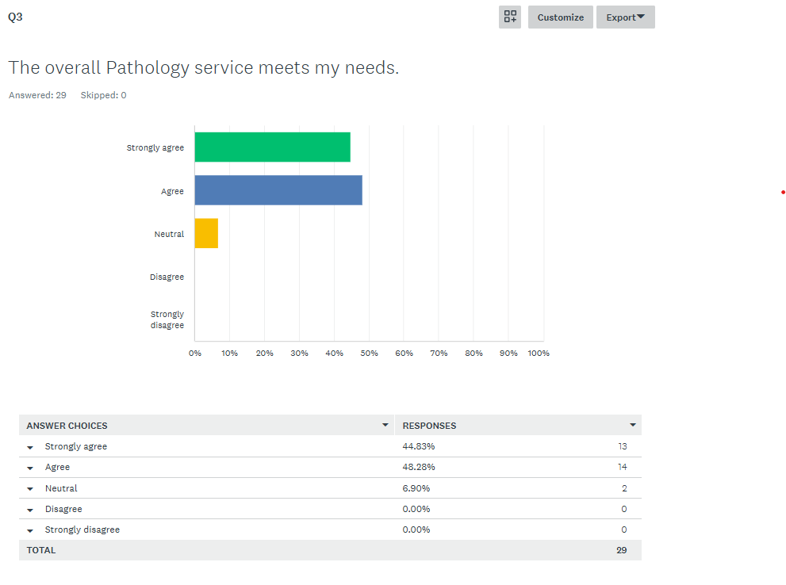
Comments: 100% user satisfaction that the service meets our user needs.

Q4: I know where to find the Laboratory Medicine User Guides (used at the Bristol hospitals) or the Pathology User Manual (used at Weston General Hospital).
Results: answered 29, skipped 0
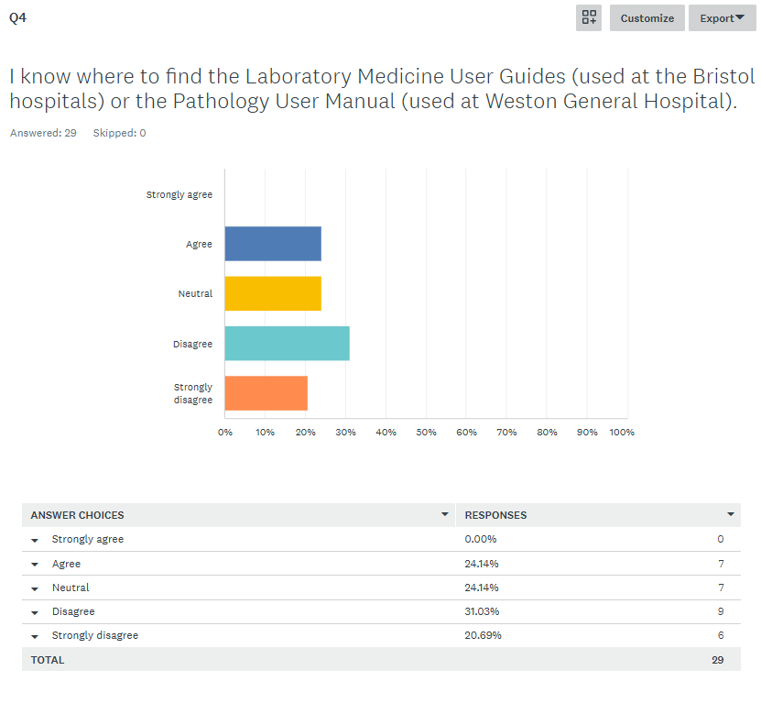
Comments: Only 24.1% of respondents know where to find the relevant user guides or manuals. Over half (51.7%) of respondents do not know where to find them. A further 24.1% are neutral or unsure. The group that did not know where to access the Laboratory guides included both GP and Nurses. Total 48% user satisfaction.

Q5: Laboratory staff are polite, knowledgeable and easy to contact:
Answered 29, skipped 0
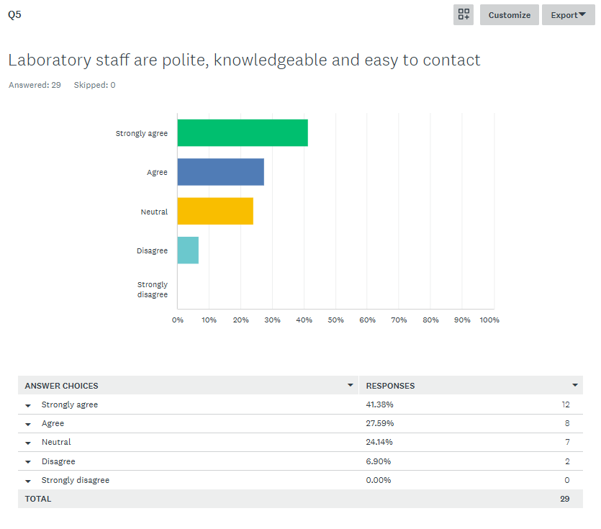
Comments: 93.1% user satisfaction, only a small portion (6.90%) expressed dissatisfaction.

Q6:The test repertoire meets the needs of my service and patients.
answered 29, skipped 0
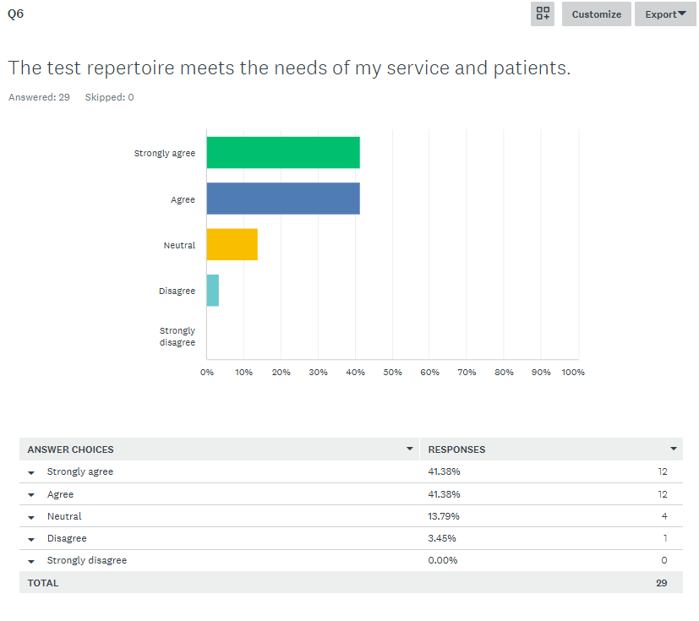
Comments: 96.55% user satisfaction, and only 3.45% disagree, with no respondents strongly disagreeing. This suggests a generally positive response to the test repertoire provided.

Q7: Results are clear, concise, easy to understand and reported within an appropriate timeframe.
answered 29, skipped 0
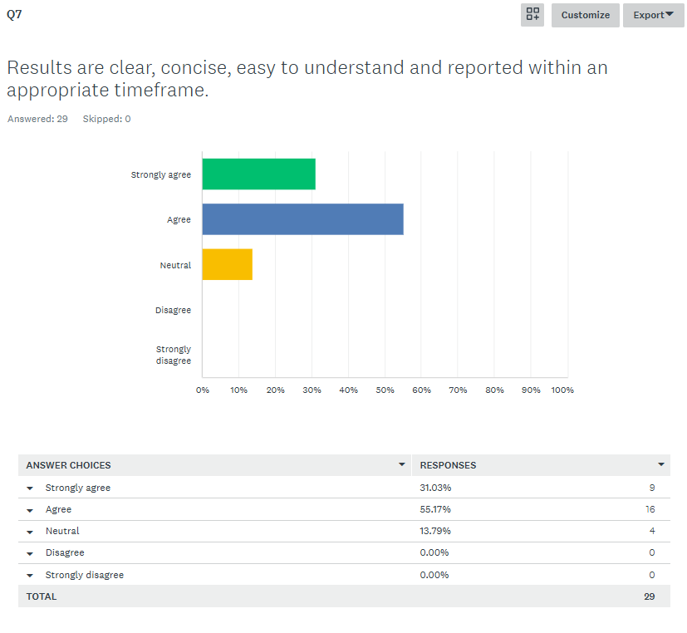
Comments: 100% User satisfaction; we meet the needs of our users.

Q8:I am able to access appropriate clinical advice about test results when required.
Results: answered 29, skipped 0
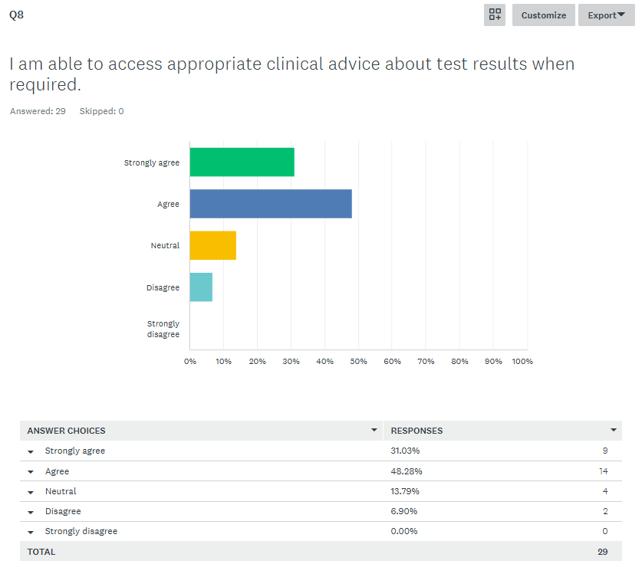Comment: Overall, a total of 93.1% of respondents agree or strongly agree that they can access appropriate clinical advice, which indicates a high level of satisfaction.

Questions 3-9 User Satisfaction Summary
The target is >90% users satisfied, by answering either strongly agree, agree or neutral.
Statement | % Satisfied (Strongly Agree - Neutral) | % Dissatisfied (Disagree - Strongly Disagree) | Assessment against Satisfaction Target (>90%)
The overall Pathology service meets my needs. | 93.1% | 6.9% | ACHIEVED
I know where to find the Laboratory Medicine User Guides or Pathology Manual. | 48.3% | 51.7% | FAILED
Laboratory staff are polite, knowledgeable and easy to contact. | 93.1% | 6.9% | ACHIEVED
The test repertoire meets the needs of my service and patients. | 96.6% | 3.5% | ACHIEVED
Results are clear, concise, easy to understand and reported within an appropriate timeframe. | 100% | 0.00% | ACHIEVED
I am able to access appropriate clinical advice about test results when required. | 93.1% | 6.9% | ACHIEVED

Question 9 &10 Comments summary:
Q9: How can we improve our pathology service to better meet your needs? (e.g. faster turnaround, clearer reports, better communication - mention department or assay if relevant. Leave contact info if you’d like a response.)
Result: answered 23, skipped 6
- Ice mail could improve. There are pages of users -I have to select page 12 and scroll down to Pathlab for each mail I send. Users from general practice only send to Pathlab... it would be nice to be able to select recent/favourite. Certain tests can't be requested and are refused when asked for as an add-on to a sample at the lab (e.g., PSA). This is not in patients' best interests, and tests which could be added to samples at the lab should be added when requested, and lab protocols adjusted to allow that. -Nurse from Charlotte Keele medical practice

- Maybe clearer communications when changes are brought in. For example, the change with the swabs was not very clear regarding how it would practically impact us (e.g., which swabs we would need to take, how many would now be needed, etc.).-GP from Charlotte Keele medical practice

- Following on from the HbA1c and B12 analyser issues last year, we felt communication was poor -particularly as we flagged a concern early on. This caused a huge backlog with workload and uncertainty for patients and staff.-Nurse from Charlotte Keel Medical Practice

- The Ice-mail system for requesting additional tests is clunky and could be improved in terms of ease of requests and results being issued/communications about things that can't be added on.-GP from Bridge View Medical

- More Lear on the outcome, where a positive blood test indicates thalassaemia trait or not, rather than just saying "ref sent."-GP from Charlotte Keel Medical Practice

- Making contact over the phone can be timely staff aren't always helpful and can appear disinterested. Emailing prep room -it would be good to get an acknowledgement email for the request, as we’re never sure if the request will be actioned. We questioned the HbA1c results prior to the analyser issue and were advised there was no problem. The following week we received communication that there was, in fact, an issue. Had this been picked up when we queried it, it would have saved a large impact on other services and excessive workload for primary care staff.-Nurse from Charlotte Keel Medical Practice

- Maybe more user-friendly comments about results, as patients can sometimes see the comments.-GP from Bridge View Medical

- ICE is not easy to search for more obscure tests. (Example: Iron studies?)-GP from Bridge View Medical

- Would like full sensitivities to be released when culture results are positive, so we do not have to ring up in the case of allergies/intolerances to antibiotics. -Nursing/Healthcare Practice

- It would be good to know about FIB-4 insufficient samples quickly or have an expected date of results when submitted.-GP from Fallodon Way,Henleaze.

- A dedicated person each day to answer the phone for lab result queries - it’s not always easy to get hold of someone and we may need to call several times.-Practice Manager from Birchwood

- I recently tried to get sensitivities for an ear swab for which the report said I had 7 days. I called BRI, was told to call NBT. They were very friendly and said they could do it, but said I needed to call BRI for confirmation. I couldn’t get through to BRI. Never got the sensitivities because time is too constrained in primary care to spend that long on the phone (including navigating all the multiple-choice automated options, etc.).-Paramedic in Primary Care from Lawerence Hill Health Centre

- Urine culture: "mixed growth" -does this mean contamination or is it still possible the patient has a urine infection; Urine microscopy - range: acceptable number of white and red blood cells?-Practice Manager from East Trees

- EBV serology (glandular fever) often goes missing when I chase it/isn’t received by the lab, but unsure why this is? Also the reprint option on ICE doesn’t work and makes my ICE crash. Then I have to re-add the same requests because it won’t let me reprint again. -Nurse from Student health service, UOB

- Sirona Community teams need to be able to access ICE to see their own results and not have to get a GP to authorise them.-PCN Manager and SB locality Non Clinical Lead from BVM

- I would like to know where to find the user guides. I have an ancient hard copy of the UHB staff handbook that has lots of contact numbers scribbled in it. It is my bible! I would love to have an up-to-date online contacts list to avoid ever going through switchboard.-GP from Whiteladies Medical Group

- It would be useful to be able to get indirect/unconjugated bilirubin.-GP from Air Balloon Surgery

- If we could add on the request without calling. The faecal calprotectin is often hard to decipher - the writing about it gets lost in with the result.-GP from East Trees Surgery

- Works well.-GP from Air Balloon Surgery

- It would be useful to have some monitoring tests grouped -both 3-month and annual - for trans patients.-GP from East Trees Surgery

- The handover from WGH to UHBW has been poor. I can't imagine anyone knows where the user guides are. The transition from WGH to UHBW has used so much resource and quite frankly been a pain in the behind.-Practice Manager from Tudor Lodge Surgery

- I only work once a week. It would be helpful if samples were kept for longer to avoid repeat testing - but I appreciate this may not be feasible. -GP from Shirehampton Surgery

- Escalation contacts if an issue would be helpful - only occasionally needed. We do have manager emails, but sometimes we get an out-of-office.- Managing Partner- Mendip Vale Medical Group.

Q10: What part of our pathology service do you feel has a positive impact on your practice? (We’d like to recognize and build on what’s working well.)
Answered 23, skipped 6
- It is good to be able to view results across the systems UHBT NBT etc it would be excellent to be able to request additional tests and receive the result to GP practice user even if sample was taken in last day or so in hospital. -Nurse from Charlotte Keel Medical Surgery

- Very responsive when contacted, very responsive and helpful if adding on requests. thank you.- GP from Charlotte Keel Medical Practice

- The staff in the labs when called through switch have always been very helpful.- GP from Bridge View Medical

- The ability to add on test to sample already taken on ice mail is an amazing thing. Very useful. Stops wasting time of getting patient back for further tests.-GP from Charlottle Keel Medical Practice

- Efficient results in timely manner. Collection from practices is regular and reliable (except on Saturdays)-Nurse from Charlottle Keel Medical Practice

- I absolutely love the ICE mail to add on tests. I was bereft when the service was suspended for the short while and noted it was available again by chance! Am very grateful to the department. Thank you, Rona Hellings. - GP from Bridge View Medical

- Rapid turnaround. -GP from Bridge View Medical

- friendly and helpful staff. – Nursing/Healthcare Assistant from Charlottle Keel Medical Practice

- The ice mail bs addon service is really good & prompt - thank you. – GP from Fallodon Way

- The guys who do the ICE helpdesk are amazing! Kath is fab! – Practice Manager from Birchwood

- All. – Nurse from Pier Health PCN

- The explanation about the test results e.g. ferritin levels - makes it easier to treat the patient as all the information is in one place. – Nurse from Students’ Health Service

- I make requests and receive results. Don't normally have any additional requirements or problems. -Paramedic in Primary Care from Lawrence Hill Health Centre

- The opportunity to discuss with a clinician the results. -Practice Manager from East Trees Surgery

- Easy to get hold of and gives useful advice. – Nurse from Student Health service, UOB

- Electronic link, results back to individuals- GP from Whiteladies Medical Group

- Ice mail. – GP from Air Balloon Surgery

- The ease of talking to be the team and how helpful they are. – GP from East Trees Surgery

- I think feedback is helpful. – GP from Air Balloon Surgery

- It’s useful when comments are added to guide us e.g. around more unusual results like rheumatology or immunology results. Contacting the lab is easy and staff are polite, friendly and helpful. Thank you. – GP from East Trees Surgery

- Honestly, I don't know. WGH had been great... now it feels anonymous. – Practice Manager from Tudor Lodge Surgery

- I always find the clinical advice really helpful when I phone the lab. – GP from Shirehampton

- Turnaround is good, alerting us of issues around results is also good. -Managing Partner from Mendip Vale Medical Group.

Laboratory Responses and Suggested Actions
Reviews and discussions of user surveys results are reported to the Laboratory’s Management meetings. These reviews and discussions allow for the formulation of plans, actions to be identified and for the Head of Department’s to respond to user’s outlining any suggestions or ideas that are to be implemented.
Question 10 Comments | Laboratory response/actions
Ice mail could improve. There are pages of users -I have to select page 12 and scroll down to Pathlab for each mail I send. Users from general practice only send to Pathlab... it would be nice to be able to select recent/favourite. Certain tests can't be requested and are refused when asked for as an add-on to a sample at the lab (e.g., PSA). This is not in patients' best interests, and tests which could be added to samples at the lab should be added when requested, and lab protocols adjusted to allow that. -Nurse from Charlotte Keele medical practice | When searching for a user, please note that you can type ‘path’ and this will filter results, rather than scrolling through pages.  The ICE system is not looked after by Laboratory Medicine, but rather UHBW Trust IT. Please contact ICE.Support@UHBW.nhs.uk with issues with access or suggestions for the system.  The laboratory aims to accept add-on requests where possible, but there are many instances where this is not possible. We will add our add-on protocol to our internet site, for improved accessibility and convenience.
Maybe clearer communications when changes are brought in. For example, the change with the swabs was not very clear regarding how it would practically impact us (e.g., which swabs we would need to take, how many would now be needed, etc.).-GP from Charlotte Keele medical practice | Our Weston and Bristol hospital sites do not have Microbiology services for swabs bacteriology and sensitivities. Samples are forwarded directly to North Bristol Trust. Please contact the Microbiology department on 0117 4146222 for Microbiology results. Our repertoire is a very limited list based on internal infection control requirements such as on-site Flu and Covid testing. Please refer to our Essential Services/Microbiology User Guide for more information: Laboratory Medicine | University Hospitals Bristol NHS Foundation Trust
Following on from the HbA1c and B12 analyser issues last year, we felt communication was poor -particularly as we flagged a concern early on. This caused a huge backlog with workload and uncertainty for patients and staff. -Nurse from Charlotte Keel Medical Practice | In October 2024, a FSN for System Incidents Affecting Multiple Patients was received of which and all recommended actions were put into place. An analysis of patient means on patients for diagnosis was monitored and an upward shift of around 2 mmol/mol was seen. The decision to continue using the analyser and keep monitoring was made until another shift was seen and we ceased testing in December 2024. Communications were provided to GP surgeries through One Care, regarding the cessation, priority interim testing by referral to another laboratory, and then recommencement of testing in January 2025 on a new analyser. The Trust has acknowledged that there are a few surgeries who do not receive communications through One Care and we understand that this is being reviewed by the Trust Communications Teams.
The Ice-mail system for requesting additional tests is clunky and could be improved in terms of ease of requests and results being issued/communications about things that can't be added on.-GP from Bridge View Medical | Please contact our Trust IT service for any ICE related issues on ice.support@uhbw.nhs.uk  The laboratory does not manage this system.
More Lear [clear] on the outcome, where a positive blood test indicates thalassaemia trait or not, rather than just saying "ref sent."-GP from Charlotte Keel Medical Practice | Thalassaemia traits can only be confirmed by genetic testing, which requires consultant haematologist approval. The screening test we perform may indicate the presence of thalassaemia traits, but we cannot confirm this onsite. We provide commentary within our reports explaining this, but do not use the phrase ‘ref sent’ as we do not refer samples for suspected thalassaemia traits. If you have further concerns, please do contact us directly to discuss this further with a specific example or discuss with a haematologist for genetic testing.
Making contact over the phone can be timely staff aren't always helpful and can appear disinterested. Emailing prep room -it would be good to get an acknowledgement email for the request, as we’re never sure if the request will be actioned. We questioned the HbA1c results prior to the analyser issue and were advised there was no problem. The following week we received communication that there was, in fact, an issue. Had this been picked up when we queried it, it would have saved a large impact on other services and excessive workload for primary care staff.-Nurse from Charlotte Keel Medical Practice | We have raised this suggestion to our Prep Room team. The automation email reply has been updated to make our processes clearer, but unfortunately, we are unable to reply individually to each email due to the volume of emails received.  Initially the shift seen with the HbA1c analyser was not clinically significant, but as you correctly say, this did change and was noticed through continual monitoring whereby the test was then halted and communications released.
Maybe more user-friendly comments about results, as patients can sometimes see the comments.-GP from Bridge View Medical | Please contact biochemadvice@uhbw.nhs.uk with specific examples to discuss where comments may be not considered user-friendly.
ICE is not easy to search for more obscure tests. (Example: Iron studies?)-GP from Bridge View Medical | Please contact our Trust IT service for any ICE related issues on ice.support@uhbw.nhs.uk  The laboratory does not manage this system.
Would like full sensitivities to be released when culture results are positive, so we do not have to ring up in the case of allergies/intolerances to antibiotics. -Nursing/Healthcare Practice | Our Weston and Bristol hospital sites do not have Microbiology services for bacteriology and sensitivities. Samples are forwarded directly to North Bristol Trust. Please contact the Microbiology department on 0117 4146222 for Microbiology results. Our repertoire is a very limited list based on internal infection control requirements such as on-site Flu and Covid testing. Please refer to our Essential Services/Microbiology User Guide for more information: Laboratory Medicine | University Hospitals Bristol NHS Foundation Trust
It would be good to know about FIB-4 insufficient samples quickly or have an expected date of results when submitted.-GP from Fallodon Way, Henleaze. | Our turnaround time for release of results or informing of any issues for these samples is 24 hours.
A dedicated person each day to answer the phone for lab result queries - it’s not always easy to get hold of someone and we may need to call several times.-Practice Manager from Birchwood | For general result enquiries, please contact our helpdesk teams.  Bristol: 0117 3423080  Weston: 01934636363 ext. 5308.
I recently tried to get sensitivities for an ear swab for which the report said I had 7 days. I called BRI, was told to call NBT. They were very friendly and said they could do it, but said I needed to call BRI for confirmation. I couldn’t get through to BRI. Never got the sensitivities because time is too constrained in primary care to spend that long on the phone (including navigating all the multiple-choice automated options, etc.).-Paramedic in Primary Care from Lawerence Hill Health Centre | Our Weston and Bristol hospital sites do not have Microbiology services for bacteriology and sensitivities. Samples are forwarded directly to North Bristol Trust. Please contact the Microbiology department on 0117 4146222 for Microbiology results. Our repertoire is a very limited list based on internal infection control requirements such as Flu and Covid testing. Please refer to our Essential Services/Microbiology User Guide for more information: Laboratory Medicine | University Hospitals Bristol NHS Foundation Trust
Urine culture: "mixed growth" -does this mean contamination or is it still possible the patient has a urine infection; Urine microscopy - range: acceptable number of white and red blood cells?-Practice Manager from East Trees | Our Weston and Bristol hospital sites do not have Microbiology services for bacteriology and sensitivities. Samples are forwarded directly to North Bristol Trust. Please contact the Microbiology department on 0117 4146222 for Microbiology result enquiries. Our repertoire is a very limited list based on internal infection control requirements such as Flu and Covid testing. Please refer to our Essential Services/Microbiology User Guide for more information: Laboratory Medicine | University Hospitals Bristol NHS Foundation Trust
EBV serology (glandular fever) often goes missing when I chase it/isn’t received by the lab, but unsure why this is? Also the reprint option on ICE doesn’t work and makes my ICE crash. Then I have to re-add the same requests because it won’t let me reprint again. -Nurse from Student health service, UOB | Please contact our Trust IT service for any ICE related issues on ice.support@uhbw.nhs.uk  The laboratory does not manage this system.
Sirona Community teams need to be able to access ICE to see their own results and not have to get a GP to authorise them.-PCN Manager and SB locality Non Clinical Lead from BVM | Please contact our Trust IT service for any ICE related issues or accounts on ice.support@uhbw.nhs.uk  The laboratory does not manage this system.
I would like to know where to find the user guides. I have an ancient hard copy of the UHB staff handbook that has lots of contact numbers scribbled in it. It is my bible! I would love to have an up-to-date online contacts list to avoid ever going through switchboard.-GP from Whiteladies Medical Group | Please find our user guides on the following link: Laboratory Medicine | University Hospitals Bristol NHS Foundation Trust
It would be useful to be able to get indirect/unconjugated bilirubin.-GP from Air Balloon Surgery | When requesting total bilirubin and direct/conjugated bilirubin, indirect/unconjugated is inferred. Indirect/unconjugated is not typically reported by laboratories as is not a measured analyte and is a less clinically useful parameter.
If we could add on the request without calling. The faecal calprotectin is often hard to decipher - the writing about it gets lost in with the result.-GP from East Trees Surgery | We have ICEMail provision for add-on requests without calling. Please see training video linked for how to use this: View Requests By Patient - ICE (Requesting & Reporting)  A summary of the reference ranges for calprotectin is as follows:  <100 µg/g - IBD unlikely  100 – 250 µg/g Indeterminate. Repeat & consider referral  >250 µg/g Organic pathology likely, suggest urgent referral
Works well.-GP from Air Balloon Surgery | Thank you.
It would be useful to have some monitoring tests grouped -both 3-month and annual - for trans patients.-GP from East Trees Surgery | Please contact our Trust IT service for any ICE related enquiries ice.support@uhbw.nhs.uk  The laboratory does not manage this system.
The handover from WGH to UHBW has been poor. I can't imagine anyone knows where the user guides are. The transition from WGH to UHBW has used so much resource and quite frankly been a pain in the behind.-Practice Manager from Tudor Lodge Surgery | Thank you for sharing your feedback. We understand that the transition from WGH to UHBW has been challenging and appreciate your honesty. The original link for WGH Pathology remains available here, https://www.waht.nhs.uk/en-GB/Our-Services1/Departments/Pathology, which contains the user guides.  If you’re unable to find what you need or have specific questions, please reach out to those detailed on the link above and we’ll be happy to assist.
I only work once a week. It would be helpful if samples were kept for longer to avoid repeat testing - but I appreciate this may not be feasible. -GP from Shirehampton Surgery | We try to maximise the time we keep samples for so that we can perform further or repeat testing as needed. The maximum storage time is based on sample stability so it would not be possible to extend these further, as results would no longer be valid.
Escalation contacts if an issue would be helpful - only occasionally needed. We do have manager emails, but sometimes we get an out-of-office.- Managing Partner- Mendip Vale Medical Group. | Please find urgent contact details on our website.  Clinical Biochemistry: Clinical Biochemistry Staff List (Including Enquiries) | University Hospitals Bristol NHS Foundation Trust  Haematology: Haematology staff list | University Hospitals Bristol NHS Foundation Trust

Question 10 Comments | Laboratory response/actions
It is good to be able to view results across the systems UHBT NBT etc it would be excellent to be able to request additional tests and receive the result to GP practice user even if sample was taken in last day or so in hospital. -Nurse from Charlotte Keel Medical Surgery | We do accept add-on requests via ICEMail. Please see the training video lesson on ‘viewing requests by Patient’ for instructions on how to do this. View Requests By Patient - ICE (Requesting & Reporting)
Very responsive when contacted, very responsive and helpful if adding on requests. thank you.- GP from Charlotte Keel Medical Practice | Thank you.
The staff in the labs when called through switch have always been very helpful.- GP from Bridge View Medical | Thank you.
The ability to add on test to sample already taken on ice mail is an amazing thing. Very useful. Stops wasting time of getting patient back for further tests.-GP from Charlottle Keel Medical Practice | Thank you.
Efficient results in timely manner. Collection from practices is regular and reliable (except on Saturdays)-Nurse from Charlottle Keel Medical Practice | Thank you.
I absolutely love the ICE mail to add on tests. I was bereft when the service was suspended for the short while and noted it was available again by chance! Am very grateful to the department. Thank you, Rona Hellings. - GP from Bridge View Medical | Thank you.
Rapid turnaround. -GP from Bridge View Medical | Thank you.
friendly and helpful staff. – Nursing/Healthcare Assistant from Charlottle Keel Medical Practice | Thank you.
The ice mail bs addon service is really good & prompt - thank you. – GP from Fallodon Way | Thank you.
The guys who do the ICE helpdesk are amazing! Kath is fab! – Practice Manager from Birchwood | Thank you.
All. – Nurse from Pier Health PCN | Thank you.
The explanation about the test results e.g. ferritin levels - makes it easier to treat the patient as all the information is in one place. – Nurse from Students’ Health Service | Thank you.
I make requests and receive results. Don't normally have any additional requirements or problems. -Paramedic in Primary Care from Lawrence Hill Health Centre | This is great to hear we are meeting your requirements.
The opportunity to discuss with a clinician the results. -Practice Manager from East Trees Surgery | Please find our clinical team contact information on our website links below:  Clinical Biochemistry: Clinical Biochemistry Staff List (Including Enquiries) | University Hospitals Bristol NHS Foundation Trust  Haematology: Haematology staff list | University Hospitals Bristol NHS Foundation Trust
Easy to get hold of and gives useful advice. – Nurse from Student Health service, UOB | Thank you.
Electronic link, results back to individuals- GP from Whiteladies Medical Group | This is great to hear.
Ice mail. – GP from Air Balloon Surgery | This is great to hear.
The ease of talking to be the team and how helpful they are. – GP from East Trees Surgery | Thank you.
I think feedback is helpful. – GP from Air Balloon Surgery | We agree. The results of this survey are published on our website for all our users to view.
It’s useful when comments are added to guide us e.g. around more unusual results like rheumatology or immunology results. Contacting the lab is easy and staff are polite, friendly and helpful. Thank you. – GP from East Trees Surgery | Thank you.
Honestly, I don't know. WGH had been great... now it feels anonymous. – Practice Manager from Tudor Lodge Surgery | Please contact our Training Manager on Donna.Connolly@uhbw.nhs.uk if you would like to arrange a tour or visit us to find out more about the department.
I always find the clinical advice really helpful when I phone the lab. – GP from Shirehampton | Thank you.
Turnaround is good, alerting us of issues around results is also good. -Managing Partner from Mendip Vale Medical Group. | Thank you.

Conclusion and Summary
This External User survey reflects the positive impact our service has had on our users and patients in primary care. There continues to be high quality service provided by Laboratory Medicine across our hospital sites at University Hospitals Bristol and Weston NHS Foundation Trust, but this report also highlights the difficulties in maintaining normal communication routes across services, during this transition phase, alongside increasing staffing and financial pressures within the Trust. The report is valuable in providing us with key areas for improvement over the next year that will most benefit our service users.
We achieved our user satisfaction target for six of the seven statements, which we feel is an accurate and positive reflection on the year. The statement that did not meet our pass mark was regarding service user ability to find our user guides, but overall the service did meet our user and patient requirements.

Actions taken and/or raised to improve over the next year:
Accessibility to user guides
Upon review, we have noticed that our add-on protocol is not published on our internet sites, and therefore, we will take this action forward, to improve the information available. All user guides on our websites contain the most up-to-date information and should be the first port of call for laboratory test information. Please see the ‘useful links’ section below for the internet site webpages.
There remains an objective to combine our Bristol and Weston separate internet sites into one UHBW Laboratory Medicine page so that users are only required to access one site for service information.
Actions to take:
- We will add the add-on protocol to the internet site.
- Merge the BRI and WGH internet pages.
Use of ICE Mail
The ICE system is not managed by Laboratory Medicine. This service is supported by UHBW Trust IT, although relevant change requests may come through to the department for review prior to implementation/rejection. ICEMail is the process for requesting additional add-on tests in the department for a sample already received at the Bristol Royal Infirmary. Please note that this process is currently not available for Weston samples, and normal phoning procedures should continue to add-on requests.
For ICE change requests, access or functionality issues, the ICE team can be contacted on the following email address: ice.support@uhbw.nhs.uk
The ICE training video can be found on the following link: View Requests By Patient - ICE (Requesting & Reporting)
Actions to take:
- We will add the add-on protocol to the internet site.
- Work with the ICE support team to update the add-on protocol link within the ICE training video.
Useful links
Current out of hours information, contact details and test information can be found within user handbooks and on our internet pages in the following links:
Bristol Royal Infirmary Laboratory Medicine internet site: Laboratory Medicine | University Hospitals Bristol NHS Foundation Trust
Weston General Hospital Laboratory Medicine internet site: Pathology (waht.nhs.uk)
Acknowledgements
We appreciate the time taken by our users to complete the survey. We continue to seek other means of feedback where possible. We are continually reviewing the service we provide to our users and continually seeking to improve wherever possible, despite the growing financial and staffing challenges we face. We will take the feedback we have gained from this survey and use it to focus our efforts.
We are grateful to all those who took the time to respond to our user survey and we hope that we will be able to address the issues you have raised so that filling in the questionnaire was time well spent. We will be repeating the User survey in the next year, to re-assess our performance and monitor any improvement.
If you want feedback on the action plan, or you did not get an opportunity to complete the user survey and want to provide feedback regarding our services please contact our Quality Manager Natalia Casey Natalia.Casey@uhbw.nhs.uk who will be happy to respond to any feedback.
If you prefer, please contact the Head of Service Adrian Brown: adrian.brown@uhbw.nhs.uk

