Introduction:
Laboratory Medicine at UHBW remains committed to delivering a high-quality, user-focused service, in line with ISO 15189:2022 – Medical Laboratories: Requirements for Quality and Competence. As part of our quality management and continual improvement processes, we undertake regular assessments of user feedback in accordance with Clause 8.4 – Evaluation and continual improvement, which requires laboratories to gather and evaluate user perceptions of the service provided.
The 2025 internal user survey focuses on feedback from UHBW staff across both the Bristol and Weston sites, including clinical teams, wards, theatres, and other departments who interact with Laboratory Medicine. This is part of our continued effort to maintain clear communication, efficient processes, and mutual understanding between the laboratory and its internal stakeholders.
Building on previous surveys—including the first combined survey conducted after the Weston and Bristol laboratory services merged—this year’s results will help guide service developments and quality improvement initiatives with direct input from those who use our service every day.

Objectives:
- To gather comprehensive feedback from internal users of Laboratory Medicine across UHBW, identifying areas of strength and opportunities for improvement in our service delivery.
- To assess how well laboratory processes and communication are supporting clinical and operational needs within the trust, including sample handling, result turnaround times, reporting clarity, and access to advice or support.
- To support ongoing service development by using real-world staff experiences to guide improvements in laboratory operations, systems, and user engagement.
- To strengthen collaboration and understanding between the laboratory and clinical departments, fostering a more efficient and patient-centred working environment.
- To fulfil ISO 15189:2022 requirements regarding the evaluation of user feedback, while embedding a culture of continuous improvement and service excellence.

Response to the Survey:
For this survey, the focus group consisted of Internal staff across University Hospital Bristol and Weston NHS foundation trust. The survey was designed by the Quality Management Team within Laboratory Medicine to gather user feedback on the service, particularly in the context of the newly implemented Managed Services Contract and the ongoing quality improvement initiatives. The survey was open for responses between 09th June 2025 and 22nd September 2025, conducted via the SurveyMonkey platform. The opening timeframe of the survey was significantly extended in order to improve the respondent count.
Respondents breakdown:
Role | Total
Doctor | 6
Nurse | 11
Nursing/Healthcare Assisstant | 2
Admin | 0
Allied Health Professional | 0
Other (Please Specify) | 1
Totals: | 20

Location of work | Bristol Royal Infirmary | Weston NHS Foundation Trust | Equally between both Bristol/Weston
TOTAL | 11 | 8 | 1

Survey Questions
Q1: What is your current job role?
Q2: Which trust site is your role predominantly based?
(Demographic questions were included to better isolate issues that maybe role or site specific)
Q3: I know where to find the Laboratory medicine user guides (used at the Bristol Royal Infirmary) or the Pathology User Manual (used at Weston NHS Foundation Trust).
Q4: Laboratory staff are always polite, helpful and professional.
Q5: Results are clear, concise, easy to understand and reported within an appropriate timeframe.
Q6: I am confident that urgent/unexpected results will be promptly communicated to be actioned.
Q7: I am able to access appropriate clinical advice about test results when require.
Q8: The Pathology service, including out of hours provision, meets the needs of my role and patients.
(The satisfaction of the above statements were graded from Strongly agree, Agree, Neutral, Disagree, and Strongly disagree. We interpreted Strongly agree, Agree, or Neutral as equal to satisfied. Disagree or Strongly disagree as dissatisfied)
Q9: How can we improve our pathology service to better meet your needs? (e.g. faster turnaround, clearer reports, better communication — mention department or assay if relevant. Leave contact info if you’d like a response.)
Q10: What part of our pathology service do you feel has a positive impact on your routine practice or workflow? (We'd like to recognise and build on what's working well)
(Two open questions were included to allow staff to express specific comments they wished to highlight)
The survey was built, distributed and collected on Survey Monkey platform.

Results
Q1: What is your current job role?
Answered 20, Skipped 0
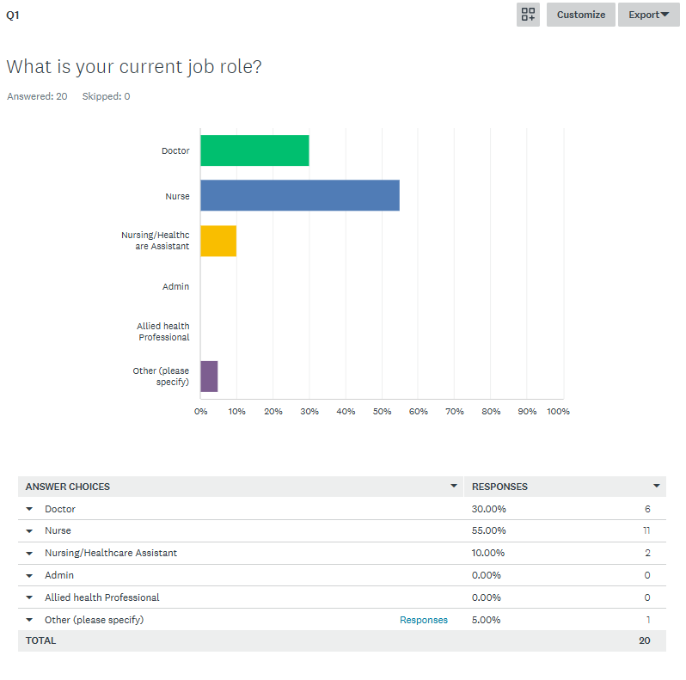
Other (please specify) responses include:
- Student Nurse
Comments: A strong number of responses came from clinical staff, particularly nurses.

Q2: Which trust site is your role predominantly based?
Answered 20, Skipped 0
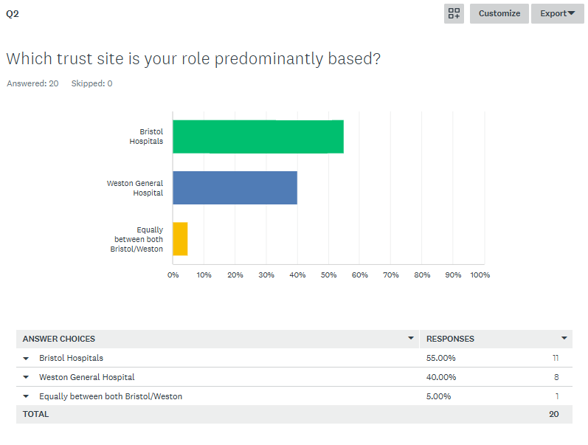
Comments: Moderate turnout across both sites, with especially high engagement from the Bristol Royal Infirmary.

Q3: I know where to find the Laboratory medicine user guides (used at the Bristol Royal Infirmary) or the Pathology User Manual (used at Weston NHS Foundation Trust).
Answered:20, Skipped 0
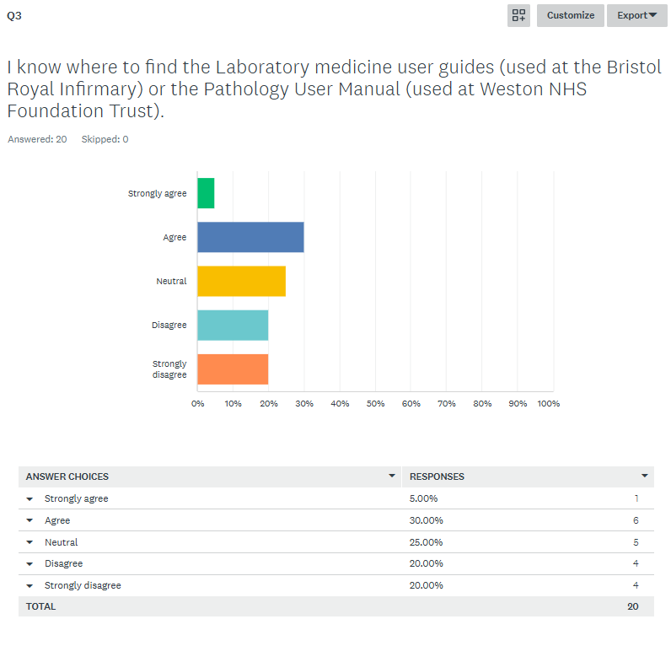Comments: Overall user satisfaction was 60%, while 40% expressed dissatisfaction (disagreeing or strongly disagreeing).

Q4: Laboratory staff are always polite, helpful and professional.
Answered 20, Skipped 0
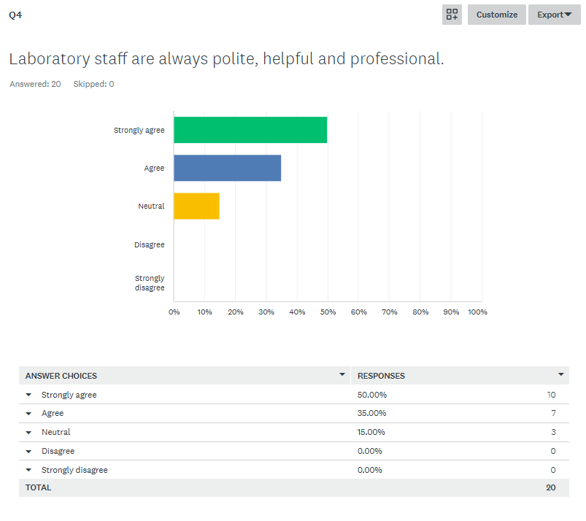
Comment: 100% User satisfaction.

Q5: Results are clear, concise, easy to understand and reported within an appropriate timeframe.
Answered 20, Skipped 0
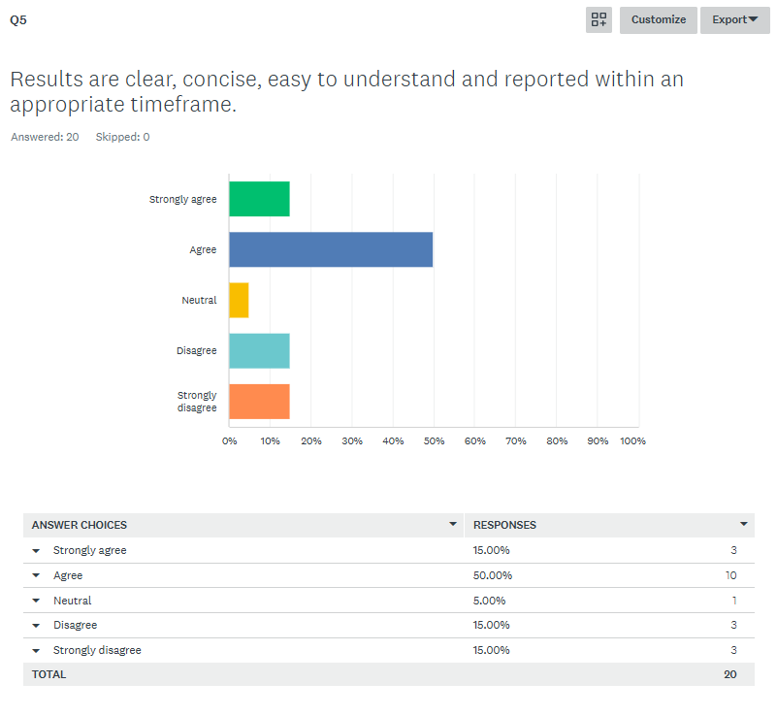
Comments 70% user satisfaction overall, with 30% expressing dissatisfaction (disagreeing or strongly disagreeing).

Q6: I am confident that urgent/unexpected results will be promptly communicated to be actioned.
Answered 20, Skipped 0.
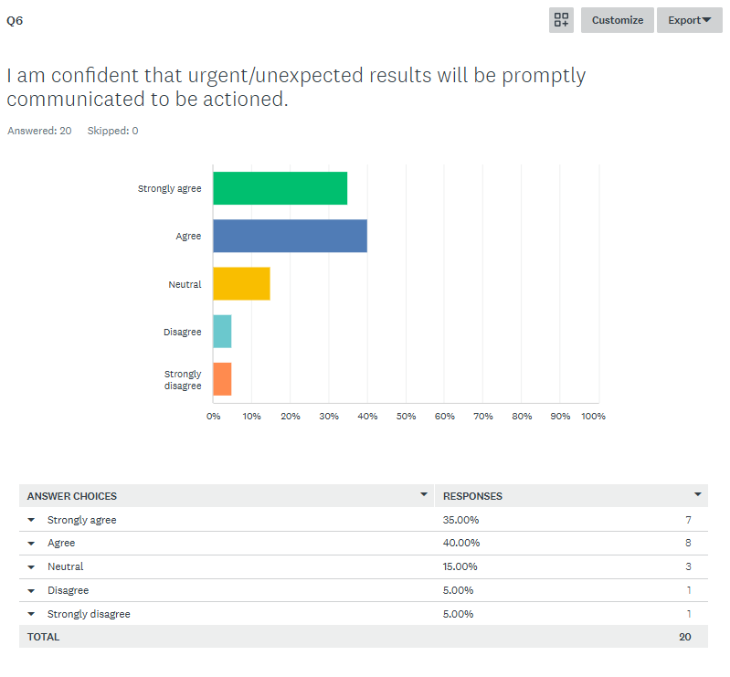
Comment: 90% of users were satisfied, while 10% expressed dissatisfaction.

Q7: I am able to access appropriate clinical advice about test results when required.
Answered 20, Skipped 0
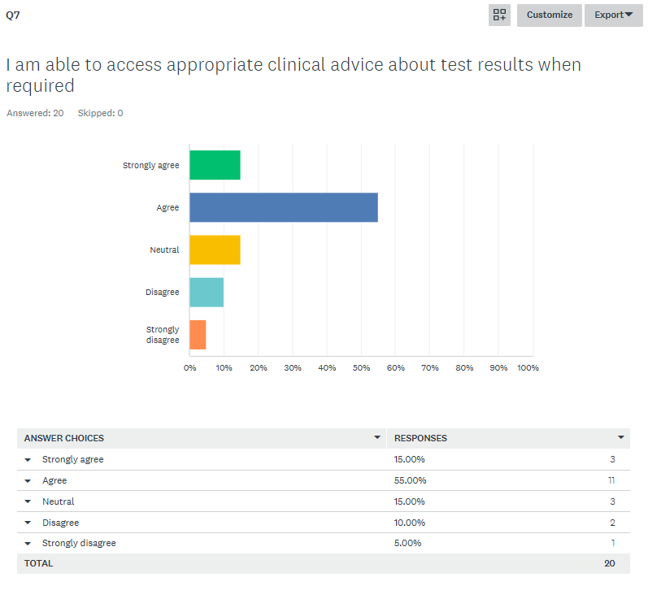
Comment: 85% user satisfaction, with around 15% reporting dissatisfaction.

Q8: The Pathology service, including out of hours provision, meets the needs of my role and patients.
Answered 20, Skipped 0
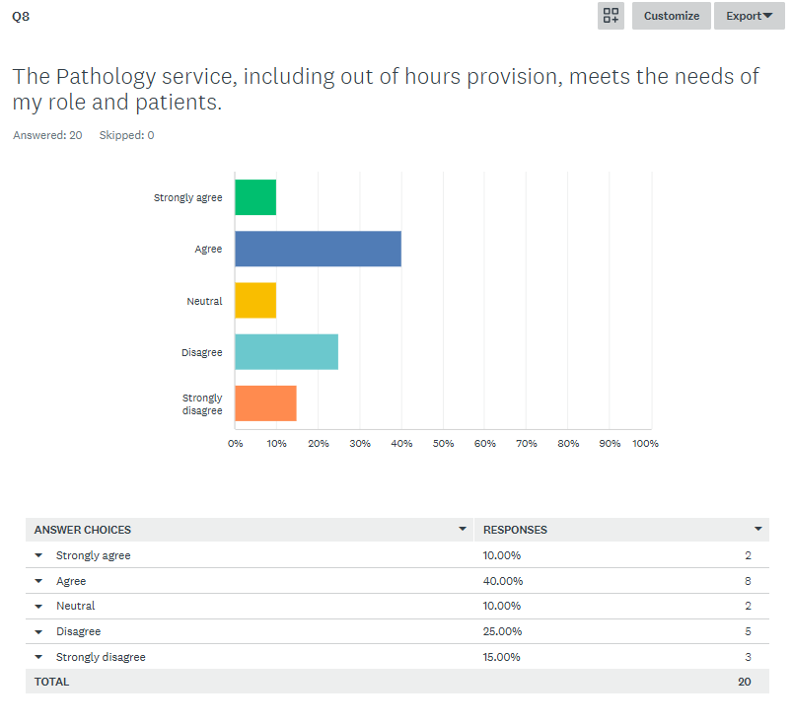
Comment: 60% of users were satisfied, while 40% reported dissatisfaction.

Questions 3-8 User Satisfaction Summary

The Target is >90% users satisfied, by answering either strongly agree, agree or neutral.
Statement | % Satisfied (Strongly Agree - Neutral) | % Dissatisfied (Disagree - Strongly Disagree) | Assessment against Satisfaction Target (>90%)
I know where to find the Laboratory medicine user guides (used at the Bristol Royal Infirmary) or the Pathology User Manual (used at Weston NHS Foundation Trust). | 60% | 40% | FAILED
Laboratory staff are always polite, helpful and professional. | 100% | 0% | ACHIEVED
Results are clear, concise, easy to understand and reported within an appropriate timeframe. | 80% | 20% | FAILED
I am confident that urgent/unexpected results will be promptly communicated to be actioned. | 90% | 10% | ACHIEVED
I am able to access appropriate clinical advice about test results when require | 85% | 15% | FAILED
The Pathology service, including out of hours provision, meets the needs of my role and patients. | 60% | 40% | FAILED

Question 9 & 10 User Comment Summary
Q9: How can we improve our pathology service to better meet your needs? (e.g. faster turnaround, clearer reports, better communication — mention department or assay if relevant. Leave contact info if you’d like a response.)
Answered 12, skipped 8
- Very helpful and knowledge staff. Out of hours it can be difficult to know who to call (e.g lp overnight etc, Southmead lab vs uhbw). I also find the way lumbar puncture results are reported is not clear- the draw of the bottle is not reported which makes it challenging to interpret the rbc. Otherwise excellent service. – Doctor from BRI site
- Staff should be helpful when we call like adding gentamicin level. They always say put an Ice mail. But once an Ice mail is made, its not pick up so better to take bloods for patient which is quicker. And most of the time, bloods taken from patient is missing. - Nurse form BRI site
- Fast turn around, things get lost all the time, I get called about results that were sent hours earlier and it’s hard to do anything about them at night when the patient has left the building- Nurse from BRI site
- Easier access to 'add on s' after blood taking please.- Nurse from BRI Site
- Answer phones calls before 9am.-Nursing/Healthcare Assistant From WGH site
- Service is meeting our needs.- Nurse from WGH Site
- Generally very prompt results sometimes delays with analyser OHDU.- Nurse from WGH Site
- Upgrade your biochemistry analyse & communicate all haemolysed or non-processed samples to the relevant requestor / dept promptly.- Doctor from WGH Site
- Don't waste the trusts money on a machine that is rubbish and now patients can be waiting several hours to get their results. -Nurse from WGH Site
- The new system has not met it's requirement, every week there is an issue with it. Delays in urgent results, sometimes over 6hrs. Thus ending up dealing with angry patients results. – Doctor From WGH
- Review of current machine analysers, as they appear to be problematic and delay patient care. Very long waiting times for certain results. - Nurse From WGH site
- Patient are waiting for long hours for blood results. - Nurse from WGH Site.

Q10: What part of our pathology service do you feel has a positive impact on your routine practice or workflow? (We'd like to recognise and build on what's working well).
- Always able to ask in hours, staff helpful and knowledge, results fast and comments on results helpful.- Doctor from BRI site
- The main desk or service desk. They should me more proactive. -Nurse from BRI Site
- Excellent service, thank you. -Doctor from BRI site
- Staff are nice.-Nurse from BRI site
- The staff are all very helpful face to face and always on the phone. Brilliant service.- Nurse From BRI site .
- Always helpful up in the lab. – Nursing/Healthcare Assistant from WGH site
- Telephone contact always works well and polite response are given by the staff who answer the call. -Nurse From WGH site
- Excellent turn around of fbc within the hour, helps reduce chemo wait times.-Nurse from WGH Site
- The attitude of the personnel. – Doctor from WGH
- Nothing. -Nurse from WGH Site
- Urgent blood tests- l work in ED and SDEC.-Doctor from WGH Site
- Investment in analysers that are more efficient. Staff usually very helpful. -Nurse from WGH Site
- All the time , they say machines problem. – Nurse From WGH Site

Laboratory Responses and Suggested actions
Reviews and discussions of user surveys results are reported to the Laboratory’s Management Meetings. These Reviews and discussions allow for the formulations of plans, actions to be identified and for the Head of Departments to respond to users outlining any suggestions or ideas that are to be implemented.
Question 9 Comments regarding improvements | Laboratory Response /Actions
Very helpful and knowledge staff. Out of hours it can be difficult to know who to call (e.g lp overnight etc, Southmead lab vs uhbw). I also find the way lumbar puncture results are reported is not clear- the draw of the bottle is not reported which makes it challenging to interpret the rbc. Otherwise excellent service. – Doctor from BRI site | Thank you. We are working to improve the contact information that is available on the new Trust intranet. Please see our new link on the sharepoint site: Laboratory medicine
Staff should be helpful when we call like adding gentamicin level. They always say put an Ice mail. But once an Ice mail is made, its not pick up so better to take bloods for patient which is quicker. And most of the time, bloods taken from patient is missing. - Nurse form BRI site | Please continue to use the ICE Mail system where appropriate as this allows for documentation of requests and makes more efficient use of the finite amount staff time available in the specimen reception area.
Fast turn around, things get lost all the time, I get called about results that were sent hours earlier and it’s hard to do anything about them at night when the patient has left the building- Nurse from BRI site | The robotic preanalytical element of our equipment reprovision has now gone live, which should significantly improve turnaround times.
Easier access to 'add on s' after blood taking please.- Nurse from BRI Site | Please continue to use the ICE Mail system where appropriate as this allows for documentation of requests and makes more efficient use of the finite amount staff time available in the specimen reception area.
Answer phones calls before 9am.-Nursing/Healthcare Assistant From WGH site | Unfortunately current staffing levels only permit these calls to be answered during core working hours. We do have a bleep for urgent out of hours information.
Service is meeting our needs.- Nurse from WGH Site | Thank you.
Generally very prompt results sometimes delays with analyser OHDU.- Nurse from WGH Site | Thank you. We try to keep such delays to a minimum. We regularly monitor and work to improve our turnaround times.
Upgrade your biochemistry analyse & communicate all haemolysed or non-processed samples to the relevant requestor / dept promptly.- Doctor from WGH Site | Thank you for your comment. The analyser provision for Clinical Biochemistry in the WGH laboratory is under review for 2026.
Don't waste the trusts money on a machine that is rubbish and now patients can be waiting several hours to get their results. -Nurse from WGH Site | The analyser provision for Clinical Biochemistry in the WGH laboratory is under review for 2026.
The new system has not met it's requirement, every week there is an issue with it. Delays in urgent results, sometimes over 6hrs. Thus ending up dealing with angry patients results. – Doctor From WGH | The analyser provision for Clinical Biochemistry in the WGH laboratory is under review for 2026.
Review of current machine analysers, as they appear to be problematic and delay patient care. Very long waiting times for certain results.- Nurse From WGH site | The analyser provision for Clinical Biochemistry in the WGH laboratory is under review for 2026.
Patient are waiting for long hours for blood results.- Nurse from WGH Site. | The analyser provision for Clinical Biochemistry in the WGH laboratory is under review for 2026.

Question 10 Comments about our positive impact | Laboratory responses
Always able to ask in hours, staff helpful and knowledge, results fast and comments on results helpful.- Doctor from BRI site | Thank you
The main desk or service desk. They should me more proactive. -Nurse from BRI Site  Excellent service, thank you. -Doctor from BRI site | Please be assured that we do our best to provide a proactive service within current staffing levels.
Staff are nice.-Nurse from BRI site | Thank you.
The staff are all very helpful face to face and always on the phone. Brilliant service.- Nurse From BRI site | Thank you
Always helpful up in the lab. – Nursing/Healthcare Assistant from WGH site | Thank you
Telephone contact always works well and polite response are given by the staff who answer the call. -Nurse From WGH site | Thank you
Excellent turn around of fbc within the hour, helps reduce chemo wait times.-Nurse from WGH Site | Thank you
The attitude of the personnel. – Doctor from WGH | Thank you
Nothing. -Nurse from WGH Site | Nothing to add
Urgent blood tests- l work in ED and SDEC.-Doctor from WGH Site | The analyser provision for Clinical Biochemistry in the WGH laboratory is under review for 2026.
Investment in analysers that are more efficient. Staff usually very helpful. -Nurse from WGH Site | The analyser provision for Clinical Biochemistry in the WGH laboratory is under review for 2026.
All the time , they say machines problem. – Nurse From WGH Site | The analyser provision for Clinical Biochemistry in the WGH laboratory is under review for 2026.

Conclusion and Summary
This Internal User survey reflects the increased pressures that the service has been under in the last year due to the implementation of our Managed Serviced Contract and many new analysers. There continues to be high quality service provided by Laboratory Medicine across our hospital sites at University Hospitals Bristol and Weston NHS Foundation Trust, but this report also highlights the difficulties in maintaining normal turnaround times during this transition phase, alongside increasing staffing pressures. The report is valuable in providing us with key areas for improvement over the next year that will most benefit our service users.
We achieved our user satisfaction target for two of the seven statements, with two of the failed statements being extremely close to our target pass mark. The statements that did not meet our pass mark included users having difficulty accessing user guides, results being reported within appropriate timeframes, accessibility to clinical advice and the service as a whole meeting user and patient needs.

Actions taken and/or raised to improve these areas:
Accessibility to user guides
In the last year, all our user guides have been published onto the MyStaff App as we recognised that many clinical teams use this repository regularly and it is the main port of call for information on procedures around the hospital. Further, our internal intranet site has been redesigned into a sharepoint webpage, with excessive information removed, and increased use of links for ease of access to relevant information. The links for the user guides on this page, direct the user straight to the document within the MyStaff app.
Results are not reported within an appropriate timeframe
Themes identified in the comments received are regarding turnaround times and delays with releasing results due to analyser issues. It is acknowledged that the implementation of our new analysers, particularly in the Clinical Biochemistry service, has required a more manual service this year than in previous years, whilst our automated sample tracking system has been verified and tested for use. We are pleased to report this has now gone live and we expect that delays in this area will significantly decrease. We also acknowledge that the analyser provision for Clinical Biochemistry is under review for 2026 in Weston and we will look to make continuous improvements here over the next year.
I cannot access clinical advice when required
Although this statement did not meet our target of 90%, the result was considerably close, at 85%. We hope that the improvements in our User Guides, and in increasing the availability of these on the MyStaff app will mean that the correct contact information will be easier to find, and therefore limit the difficulties experienced. Developments on our newly combined UHBW Sharepoint site, have also now summarised and highlighted contact information for key areas more succinctly than before.
The pathology service does not meet the needs of my role and patients
To ensure that our current repertoire meets need, we constantly review the tests we are providing in terms of their suitability, turnaround times and workloads to ensure we provide the best possible service. We are committed to continually improving our services and value the feedback that has been provided. This feedback will be used to guide future improvement measures and is discussed at our governance meetings. Please do contact us directly if you have specific requirements that are not currently under our provision and we will do our best to assist you.
Useful links
Current out of hours information, contact details and test information can be found within user handbooks and on our intranet and internet pages in the following links:
Laboratory Medicine (UHBW) intranet: Laboratory medicine
Bristol internet: Laboratory Medicine | University Hospitals Bristol NHS Foundation Trust (uhbristol.nhs.uk)
Weston internet: Pathology (waht.nhs.uk)
Acknowledgements
We appreciate the time taken by our users to complete the survey. We continue to seek other means of feedback where possible. We are continually reviewing the service we provide to our users and continually seeking to improve wherever possible, despite the growing financial and staffing challenges we face. We will take the feedback we have gained from this survey and use it to focus our efforts.
We are grateful to all those who took the time to respond to our user survey and we hope that we will be able to address the issues you have raised so that filling in the questionnaire was time well spent. We will be repeating the User survey in the next year, to re-assess our performance and monitor any improvement.
If you want feedback on the action plan, or you did not get an opportunity to complete the user survey and want to provide feedback regarding our services please contact our Quality Manager Natalia Casey Natalia.Casey@uhbw.nhs.uk who will be happy to respond to any feedback.
If you prefer, please contact the Head of Service Adrian Brown: adrian.brown@uhbw.nhs.uk

