University Hospitals Bristol and Weston NHS Trust

Department of Laboratory Medicine

Bristol Royal Infirmary, Marlborough Street, Bristol, BS1 8HQ
Phone: 0117 3423080 (Pathology helpdesk)
Weston General Hospital, Grange Road, Uphill, Weston Super Mare
North Somerset. BS23 4TQ
Phone: 01934 636363: ext. 3305 Direct Dial 01934 647053

Microbiology Service
User Guide

Essential guidelines for staff that use
University Hospitals Bristol and Weston Trust
Microbiology Services at
Bristol Royal Infirmary and Weston General Hospital

INDEX

1.0 Scope of document 3
2.0 General information 3
2.1 General Contact Information and Clinical Advice contact information 3
2.2 Microbiology Contact List and General Enquiries 4
2.3 Contact guidelines for Duty Clinical Microbiologist @ Weston only 5
3.0 Sample collection 6
3.1 Sample labelling 6
4.0 Blood Cultures 6
5.0 Containment Level 4 Organisms 6
6.0 Microbiology investigations 7
6.1 Service provider updates 7
7.0 Antigen and molecular detection – on-site testing in the ESL- Weston 7
7.1 Testing services provided by Bristol Royal Infirmary Essential Services Laboratory 10
8.0 ESL in-house turnaround times 12
9.0 Southmead infection sciences turnaround times 12
10.0 Test preparation and sample containers 12
10.1 Requesting 12
10.1.1 Form Completion 13
10.1.2 Electronic Requesting 13
11.0 Microbiology sample container description 13
12.0 Routine and out of hours service 15
12.1 Out of normal routine hours (including Public Holidays) 15
12.2 Microbiology tests available by telephone request (Urgent samples) 15
13.0 Test result reporting 16
14.0 Trust antimicrobial policy 16
14.1 Antibiotic levels 16
15.0 Governance – Quality Standards 17
15.1 United Kingdom Accreditation Service (UKAS) 17
15.2 Health and Safety Executive (HSE) 17
16.0 Appendix 1 - notification of infectious diseases 18

Microbiology User Guide

Scope of document
This document is a User Manual which describes the services provided by the microbiology division within Pathology at University Hospitals Bristol and Weston NHS Foundation Trust. The document is designed for use by all users of the service and the information contained herein is correct as of the time of printing.

General information
- The Microbiology service for Hospital users and local community GP’s is provided, in the main, by the UK Heath Security Agency (UKHSA) based at Southmead Hospital, Telephone 0117 414 6222.
- This facility provides a comprehensive high quality, medically led service. For specialist tests, this facility refers samples to appropriate nationally accredited Reference Laboratories across the UK.
- UHBW NHSFT has a contract with UKHSA for bacteriological, virological and serological investigations.
- We are happy to meet all interested staff to discuss matters pertaining to Microbiology and to receive any feedback regarding our service. Whether it be Medical, Scientific, Computing or Clerical please contact us during normal laboratory hours.
- Laboratory services are provided by Biomedical Scientists (BMSs), MLAs (Medical Laboratory Assistants), and Consultant Laboratory Medical Staff.
- The Medical Microbiology laboratory at Southmead provides services to the Bristol and Weston Area General Practice Surgeries in conjunction with the Hospital patients and clinics.
- Deliveries are made to the hospital throughout the working day, from various surgeries in the local area.
- This Microbiology work is packaged for dispatch to UKHSA Southmead for processing, without further handling or input.
- Weston Hospital and Bristol Royal Infirmary host a Microbiology Essential Services Laboratory, [ESL], to provide a limited repertoire of on-site tests. This includes testing for C. difficile toxin, respiratory viruses, Norovirus and Covid-19 (see table in section 6 for each laboratory services provided).
- Weston Hospital and Bristol Royal Infirmary host Blood Culture incubators on both sites, within Pathology, to support the out-sourced Microbiology service provided by UKHSA.
- All Blood Culture bottles are incubated on the site of origin, and any bottles that yield a positive result are transferred to UKHSA for further testing.
- Results of all tests generated by both laboratories are entered into the laboratory computer system as soon as they are available and reports are issued daily. Results judged to be of clinical urgency or relevance is made known to the responsible clinician as soon as they become available. Isolates of public health significance or of importance for hospital cross infection are reported directly to the relevant person.

General Contact Information and Clinical Advice contact information
For public health advice and advice on Meningitis and infectious disease notification please call 0300 3038162.

Laboratory Availability
- Routine Hours for UKHSA at Southmead are 08.30 – 20:00 Monday - Friday (exc. Public Holidays)
- On Saturday and Sunday mornings and Public Holidays, UKHSA at Southmead provide a routine service 08:00 – 17:00 (see below), with an ion-call service at all other times.
- Routine Hours for the Microbiology Essential Services laboratory at Weston General are 08.30 – 17:00 Monday - Friday (exc. Public Holidays)- Service is provided 24/7 with reduced staff outside of routine hours.
- Routine Hours for the Microbiology Essential Services laboratory at Bristol Royal Infirmary are 09:00 – 17:30 Monday - Friday (exc. Public Holidays). Service is provided 24/7 with reduced staff outside of routine hours.
- On Saturday and Sunday mornings and Public Holidays, The Microbiology Essential Service Laboratory at Weston General can be reached on 01934 647053 or ext. 3305 between 08:30 – 12:00 (see below).

Microbiology Contact List and General Enquiries
Microbiology
Medical Microbiologists: |  |  | Monday - Friday
Duty Consultant Clinical Microbiologist | 01934 636363 Ext 5304  Or 01934 881304  See notes below | WGHClinicalMicrobiology@uhbw.nhs.uk | Monday - Friday
Microbiology Laboratory Southmead | 0117 414 6222 |  | Monday - Friday
Head Biomedical Scientist:  Mrs Nicola Childs | Tel: 0117 4146218  Mob: 07800915205 | Nicola.childs@nbt.nhs.uk | Monday - Friday
Microbiology laboratory:  For routine enquiries | 0117 414 6222 |  | Monday - Friday
Bristol Royal Infirmary Clinical Enquiries:  Medics/Consultant Microbiologist | via extension 29269 or 29270 |  | Monday - Friday
Essential Services Laboratory Weston: | 3305  01934 647053 |  | Monday - Friday
Head Biomedical Scientist:  Mr Mark Woodward | 3303  01934 647017 | Mark.woodward2@uhbw.nhs.uk | Monday - Friday
Microbiology laboratory:  For routine enquiries | 3305  01934 647053 |  | Monday - Friday
Infection Control | 01934 636363 Ext 3025 + Bleep 4141 |  | Monday – Friday
Essential Services Laboratory Bristol Royal Infirmary: | Via Pathology Helpdesk  (0117 3423080). |  | Monday - Friday
Head Biomedical Scientist:  Mr Mark Woodward | 3303  01934 647017 | Mark.woodward2@uhbw.nhs.uk | Monday - Friday
ESL Quality Lead:  Mr Nicholas Veasey | 0117 3427833 | Nicholas.Veasey@uhbw.nhs.uk | Monday - Friday

Contact guidelines for Duty Clinical Microbiologist @ Weston only
- To streamline our service provision and ensure enquiries can be managed in a timely way, we first ask that all practitioners consult their local antimicrobial guidance (MicroGuide / Primary Care guideline) before calling for microbiology clinical advice.
- Much of the routine local guidance can be found within these guides:
- MicroGuide: https://viewer.microguide.global/UHBRISTOL/
- Primary Care Guidelines: https://remedy.bnssg.icb.nhs.uk/
- Within working hours (Mon-Fri 9am to 5pm) clinical advice can be sought via: - Telephone: 01934 881304. Please note, the service is staffed by a single Consultant Microbiologist, and calls cannot be answered immediately at all times, due to our busy clinical schedule.

Hospital Clinician enquiries@ Weston only
- We request that non-urgent enquiries are made through the methods highlighted below (CareFlow referral for inpatients and email referral for primary care patients).
- Otherwise, we will endeavour to protect time to answer calls between 12:00 - 13:00 and
15:30 - 16:30. If your call is not immediately answered or the line is engaged, you may need to call back after 15-30 mins.
If your query is non-urgent, inpatient enquires can be submitted via CareFlow to Microbiology Clinical Advice*.
- Queries will be answered within the same working day, if received before 4pm.
- Enquires received after 4pm will be dealt with in the next working day.
- CareFlow MUST NOT be used for out of hours or urgent enquiries.

Primary Care Clinician Enquiries@ Weston only
- Primary care non-urgent enquires can be emailed through to our Clinical Advice email address*: WGHClinicalMicrobiology@uhbw.nhs.uk
- Please note, queries will be answered within the same working day, if received before 4pm.
- Enquires received after 4pm will be dealt with in the next working day.
- Emails MUST NOT be used for out-of-hours or urgent enquiries.
- If your enquiry is urgent and there is no response from 01934 881304, please go through to the NBT Bacteriology Clinical Advice telephone line on 0117 414 6222. Please note, this is for urgent enquiries only, that require an immediate response
- All out-of-hours calls (5pm to 9am, weekends and bank holidays) must go through switchboard to the on-call Microbiologist at NBT, who covers both NBT and Weston General out of hours.
- This service is for urgent out-of-hours enquires only, which are required to optimise patient care out of hours.
- Non-urgent enquiries should be discussed in working hours.
- Inappropriate use of the out-of-hours service will be escalated to senior leaders for review

*For both CareFlow referrals and primary care email referrals, we require the below minimum information (if enquiries are received with insufficient detail, they will be rejected, asking for more information): -
- Name / Grade (job title) of referrer.
- Responsible Consultant / Specialty (if applicable).
- Contact details (bleep and/or direct extension and/or mobile number) for the referrer (or the correct person to contact for the next working day, if applicable).
- Patient details (not applicable for CareFlow, as referral to be made through the patient record)
- Name / NHS No. / DoB / Location.
- Brief clinical summary - As much detail as possible around past and present antimicrobials and drug allergies.
- The question to Medical Microbiology.

Sample collection

Sample labelling
- It is imperative that any sample taken from a patient can be identified using 3 patient identifiers. Without this minimum information, a sample cannot be guaranteed to be processed. To do so, the minimum requirement for identification is:
- Surname
- Forename
- Hospital registration number or date of birth or NHS number
- Upon receipt, most microbiology samples are packaged without further intervention by UHBW Pathology staff, to be sent to UKHSA for testing.
- At Weston, this is managed by the Weston ESL Team
- At BRI, this is managed by the BRI Specimen Reception Team
- At this stage the requests will not be logged, meaning that there will be no record of receipt of a sample, until it is registered on the local LIMS by UKHSA.

Blood Cultures
- One exception to the above is the receipt of Blood Cultures from the UHBW sites.
- In this instance, all samples will be registered upon arrival and incubated without delay.
- Any Blood Culture set that yields a positive result will be dispatched to UKHSA for further testing.

Containment Level 4 Organisms
Certain organisms are classified as being Containment Level 4 by the Advisory Committee on Dangerous pathogens (ACDP). Samples should NOT be taken or sent to the laboratory from patients suspected as having the following diseases without consulting the Medical Microbiologist, Head BMS and referring to the relevant Trust policy:

- Viral Haemorrhagic Fever (VHF) – See Trust VHF policy
- Creutzfeldt Jakob Disease (vCJD) – See Trust CJD / TSE Policy
- Rabies – See Trust HCID policy
- Anthrax See Trust HCID Policy

- Likewise for Containment Level 4 organisms, please ensure that the request form is clearly labelled as ’DANGER OF INFECTION’ and use unambiguous and commonly recognised terminology. Failure to do this may result in risk to laboratory staff.

Microbiology investigations
- General Bacteriology;
- Priority Specimens [CSF/ Sterile fluids / Tissues]
- Mycology
- Parasitology
- Mycobacterial investigation
- Miscellaneous PCR
- Serological tests
- Antifungal drug assays

Performed at Southmead UKHSA, please refer to the Southmead Infectious Sciences User Manual
Southmead Infection Sciences User Manual

Service provider updates
N.B. With effect from 7th January 2025, UKHSA Bristol will no longer perform microscopy for urinary casts. Please contact the laboratory at NBT directly on 01174146222 if you wish to discuss this further
N.B. With effect from 1st August 2025, UKHSA Bristol will no longer perform urinary antigen testing for Streptococcus Pneumoniae. Please contact the laboratory at NBT directly on 01174146222 if you wish to discuss this further

Antigen and molecular detection – on-site testing in the ESL- Weston
Investigation | Sample Type | Container | Pre-analytical Storage | Post-analytical Storage | Notes
Influenza A, B and RSV (Respiratory Viruses) by PCR | Viral throat swab  1ml or  3 ml tube is acceptable.  Please ensure there is liquid in the tube before sending to the laboratory | Viral swab container with green, purple, or red top | Refrigerate for up to 24 hrs if necessary; immediate dispatch for testing is preferred | Samples are stored in the fridge for seven days after testing | All negative samples from patents under the age of 16, and those with a specific clinical request, will be referred to UKHSA for full respiratory panel testing.  Performed on site by the Essential Services Laboratory  Positive samples will be referred to UKHSA Bristol for further testing, dependent upon results, for further information, please contact the laboratory
Clostridium difficile – toxin testing  Weston ONLY | Faeces samples  [Please send a minimum of 10ml of faeces] | Sterile 30 ml. plastic universal container with spoon | Refrigerate for up to 24 hrs if necessary; immediate dispatch for testing is preferred | Refrigerate (stored for 4 days or frozen for 1 year if positive) | 5-20g (or ml) sample required. This test can be performed from the same sample requested for Norovirus or Bacterial PCR. Please ensure that all required tests are requested and that all necessary ICE labels are attached to the sample[s]. Please include details of current or previous anti-microbial therapy  Please discuss if there are concerns regarding the presence of interfering substances in the sample due to patient’s current treatment  Performed on site by the Essential Services Laboratory  Positive samples may be referred to UKHSA Leeds for further testing, dependent upon results, for further information, please contact the laboratory
Norovirus by PCR  Weston ONLY | Faeces or vomit samples  [Please send a minimum of 10ml of faeces | Sterile 30 ml. plastic universal container with spoon | Refrigerate for up to 24 hrs if necessary; immediate dispatch for testing is preferred | Refrigerate (stored for 4 days or frozen for 1 year if positive) | Will only be processed once per patient per hospital stay, unless the hospital is experiencing a Norovirus outbreak, whereupon repeated testing may be indicated. This test can be performed from the same sample requested for C. difficile or Bacterial PCR. Please ensure that all required tests are requested and that all necessary ICE labels are attached to the sample[s]. Some test interference can occur with excess haemoglobin, mucin, cholesterol, triglycerides or whole blood in the sample. Please discuss if there are clinical concerns.  Performed on site by the Essential Services Laboratory Positive samples may be referred to UKHSA for further testing, dependent upon results, for further information, please contact the laboratory.
COVID-19 testing by Cepheid | Viral nose and throat swab  1ml or  3ml tubes are acceptable Please ensure there is liquid in the tube before sending to the laboratory | Viral swab container green, purple, or red lids. | Refrigerate for up to 24 hrs if necessary; immediate dispatch for testing is preferred | Samples are stored in the fridge for seven days after testing, Positive samples are referred to UKHSA for Genotyping | All negative samples from patents under the age of 16, and those with a specific clinical request, will be referred to Bristol for full respiratory panel testing.  Performed on site by the Essential Services Laboratory  Positive samples will be referred to UKHSA Bristol for further testing, dependent upon results, for further information, please contact the laboratory.

7.1 Testing services provided by Bristol Royal Infirmary Essential Services Laboratory
Investigation | Sample Type/Container | Pre-analytical Storage | Post-analytical Storage | Notes
Biofire Respiratory Panel 2.1+ Assay including: Adenovirus, Coronavirus 229E, Coronavirus HKU1, Coronavirus NL63, Coronavirus OC43, Severe Acute Respiratory Syndrome Coronavirus 2 (SARS-CoV-2), Human Metapneumovirus, Human Rhinovirus/Enterovirus, Influenza A/H1, Influenza A/H1-2009, Influenza A/H3, Influenza B, Middle East Respiratory Syndrome Coronavirus (MERS-CoV), Parainfluenza Virus 1, Parainfluenza Virus 2, Parainfluenza Virus 3, Parainfluenza Virus 4, Respiratory Syncytial Virus (RSV), Bordetella Parapertussis, Bordetella pertussis, Chlamydia pneumoniae and Mycoplasma pneumoniae. | Nasopharyngeal swab (NPS) collected according to standard technique and immediately placed in up to 3mL of transport media or saline.  MWE Medical Wire  Sigma Virocult Virus Transport Medium 1ml Or  Copan UTM RT MINI 1ml Transport medium for viruses.  Please ensure there is liquid in the tube before sending to the laboratory. | Specimens should be tested with the Biofire RP2.1 as soon as possible.  If storage is required, specimens can be held:  At room temperature for up to 4 hours (15-25°C).  Refrigerated for up to 3 days (2-8°C).  Frozen (≤-15°C or ≤-70°C) (for up to 30 days). | Sample are stored in the cold room for seven days after testing, samples identified as positive for Covid-19, Influenza A, B or Mycoplasma Pneumoniae are referred to UKHSA based at Southmead Hospital for further investigations | Samples must be sent to the laboratory in a red or ED urgent green sample bag or otherwise marked ‘Rapid’ if these bags are unavailable.  BioFire testing is conducted in-house for paediatric patients, while samples from adult patients are sent to Southmead for analysis.  Onsite Biofire assay is currently a non-accredited ISO 15189:2022 test.  MERS-CoV-2 assay is unverified.

Investigation | Sample Type | Pre-analytical Storage | Post-analytical Storage | Notes
Severe Acute Respiratory Syndrome Coronavirus 2 (SARS-CoV-2)  tested on the Cepheid GeneXpert using the Xpert Xpress SARS-CoV-2 Assay Kit. | Nasopharyngeal, oropharyngeal, nasal, or  mid-turbinate swab collected and placed into a  viral transport tube.  MWE Medical Wire  Sigma Virocult Virus  Transport Medium 1ml Or Copan UTM RT MINI 1ml Transport medium for viruses. | Samples can  be stored for  up to 8 hours at room  temperature (15-30°C ) or  up to 7 days if stored 2-8°C . | Sample are stored in the cold room for seven days after testing, samples identified as positive for Covid-19 are referred to UKHSA based at Southmead Hospital for further genotyping. | Samples must be sent to the laboratory in a red or ED urgent green sample bag or otherwise marked ‘Rapid’ if these bags are unavailable. All non-rapid samples are referred to WGH laboratory.  Onsite COVID-19 PCR is currently a non-accredited ISO 15189 Test.
Severe Acute Respiratory Syndrome Coronavirus 2 (SARS-CoV-2),  Influenza A, Influenza B and RSV  tested on the Cepheid GeneXpert using the Xpert Xpress SARS-CoV-2, Influenza A/B and RSV Plus Assay Kit. | Nasopharyngeal, oropharyngeal, nasal, or  mid-turbinate swab collected and placed into a  viral transport tube.  MWE Medical Wire  Sigma Virocult Virus  Transport Medium 1ml Or Copan UTM RT MINI 1ml Transport medium for viruses. | Samples can  be stored for  up to 8 hours at room  temperature (15-30°C) or  up to 7 days if stored 2-8°C. | Sample are stored in the cold room for seven days after testing, samples identified as positive for Covid-19, Influenza A or B are referred to UKHSA based at Southmead Hospital for genotyping. | Samples must be sent to the laboratory in a red or ED urgent green sample bag or otherwise marked ‘Rapid’ if these bags are unavailable. All non-rapid samples are referred to WGH laboratory.  Onsite Influenza A, B and RSV PCR is currently a non-accredited ISO 15189 Test.

ESL in-house turnaround times
The final identification and susceptibility testing of some organisms can take much longer than indicated and may need referral to a reference laboratory. In this situation interim results will be issued as soon as practicable.

Weston ESL Tests
Turnaround times are measured from the time of receipt to availability of report in 90% of cases
Sample | Turnaround time
Respiratory Virus [inc. Covid] | 1.5 Hours
Clostridium. Difficile | 24 Hours
Norovirus | 24 Hours

Bristol Royal Infirmary ESL tests
Turnaround times are measured from the time of receipt to availability of report in 90% of cases
Sample | Turnaround time
Respiratory Virus testing using Biofire Platform | 2 Hours
Multiplex Respiratory Virus [inc. Covid] testing using Cepheid Platform | 2 Hours

Southmead infection sciences turnaround times
- For all investigations performed at Southmead Microbiology, please refer to the Southmead Infectious Sciences User Manual
Southmead Infection Sciences User Manual

Test preparation and sample containers

Requesting
- For all requests, please provide accurate and appropriate clinical details. This will allow the laboratory to correctly process and interpret specimens and their results. Clinical details include antibiotic treatment, clinical signs and symptoms, foreign travel, immune status and dates of onset.

Form Completion
- Ideally, most requests will now be made electronically through the ICE system.
- Where this is not the case or during downtime we will accept paper request forms, however it is important that they are filled in correctly. For guidance on the completion of request forms, including the minimum criteria for positive patient identification, please refer to the Pathology User Guide.

Electronic Requesting
- Where possible, please use the electronic requesting system ICE for requesting tests. This enables a more rapid receipt and processing of samples within the laboratory. Please also ensure that the specimen is labelled with an ICE produced sticker (barcoded) before sending the specimen to the laboratory in the specimen bag.
- Please ensure that you have selected the correct test and obtained the correct sample for this request before sending the specimen to the laboratory. Failure to do this may result in incorrect tests being performed or rejection of samples for processing.

Microbiology sample container description

Swab Container types
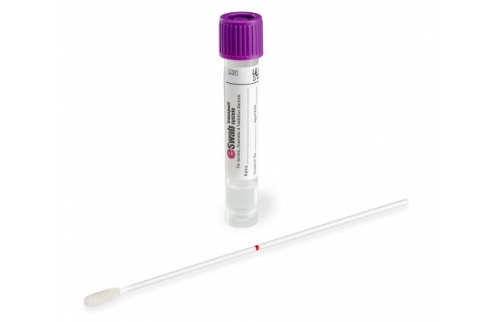 |  | Purple topped, liquid trans-swab, for routine bacterial culture
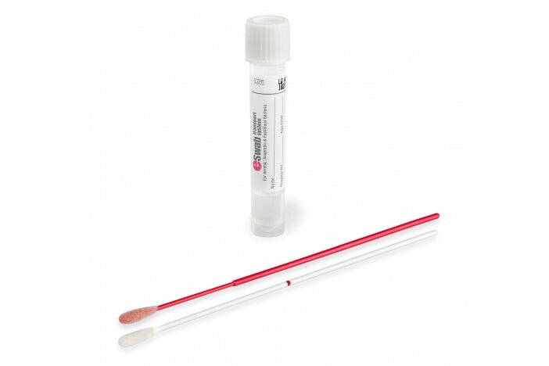 |  | White topped, liquid trans-swab, for MRSA / MSSA culture
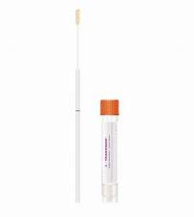 |  | Orange topped fine shafted swab for Urethral swabs for culture
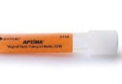 |  | Aptima vaginal swab pack with orange tube
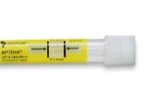 |  | Aptima urine pack with yellow tube
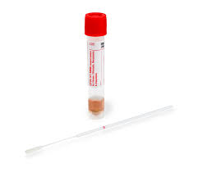  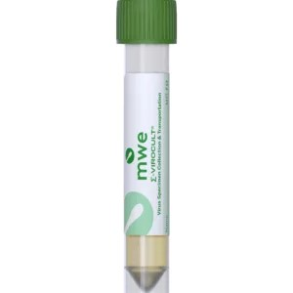 |  | Viral swab pack with red tube. Note that lids could also be purple or green in some cases. This is appropriate for Herpes, Covid/Flu and Whooping Cough testing.
Specimen containers - continued
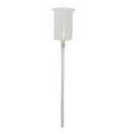 | 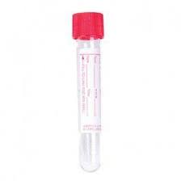 | Red lidded Boric Acid tubes with collection transfer device – 10ml (for Microbiology ONLY)
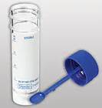 |  | Blue universal with spoon – 30ml [faeces]
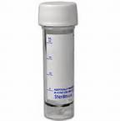 |  | Plain universal 30ml pot [Sputum / Fluids / CSF]
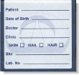 |  | Myco-Trans envelope containing sealable package  [ Mycology]
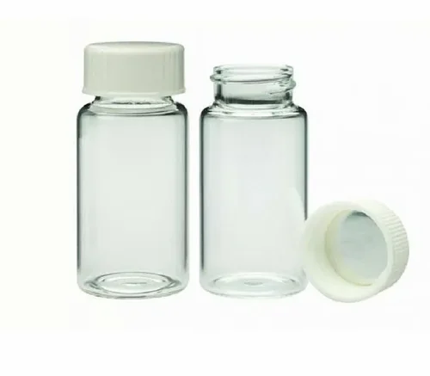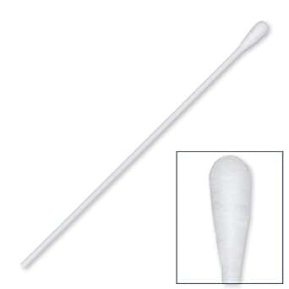 |  | Cotton tipped swab with 5ml saline vial  [Threadworm]
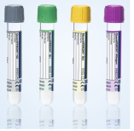 |  | Quantiferon tubes x4 pack – available from Microbiology
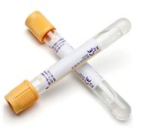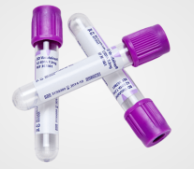 |  | Serology blood tubes – yellow SST (general serology) and purple EDTA (viral load)

Routine and out of hours service

Out of normal routine hours (including Public Holidays)
- The microbiology out of hours service is for essential urgent requests only. If you require an urgent microbiology request, contact the OOH Blood Science BMS on bleep 4017 – Weston or Specimen reception at the BRI, on extension 0117 3423080
- N.B. It is the responsibility of the requesting clinician to; -
- 1, To contact Weston Pathology staff when an urgent sample is taken to the lab.
- 2, To contact the on-call Microbiology BMS @ Southmead, who will arrange collection of the sample from Weston, the processing of the sample @ Southmead, and the telephoning of results to the requesting clinician.
- The Weston OOH Blood Sciences BMS will provide details of contact numbers and record the dispatch of the sample for audit purposes.
- On Saturday, Sunday and Public Holiday mornings, the Microbiology Laboratory @ Southmead will be staffed between 8 am and 5pm, some routine and all urgent work will be processed.

Microbiology tests available by telephone request (Urgent samples)

Department | Urgent work during routine hours | Urgent work out of hours
Microbiology | Telephone requests and specified requests for result to be phoned | Microscopy and culture for CSF
Microbiology |  | Joint fluids and Ascitic fluids

- Please phone urgent test requests in advance during routine hours to the ESL at Weston, or Specimen reception at the BRI.
- Please phone urgent test requests in advance out of hours to the on-call BMS @ Southmead to ensure that upon arrival they are processed accordingly.
- No notification of an urgent request may result in a significant delay in processing.
- It is the responsibility of the requesting clinician to ensure that the laboratory is informed of an urgent sample. It is also best practice to highlight upon the request that the sample is to be urgently processed and to provide a bleep number.
- All out of hours investigations will be entered on completion, onto the Pathology computer system and can be accessed on ICE, with the appropriate password, from any network PC terminal in the hospital. All urgent results will be telephoned upon request. Please provide a bleep or other contact number with the sample.

Test result reporting
- All test results will be available on ICE; these results will include reference ranges [where appropriate] and clinical interpretation of the clinical significance of the results in the report. This interpretation will be guided by biological reference intervals for each specific analysis, details of which are available upon request from the laboratory, using the contact numbers above in 2.2.1.

Trust antimicrobial policy
- Gentamicin and Vancomycin Antibiotic level testing is performed in Biochemistry.
- Other assays, including Amikacin and Teicoplanin are referred to the Anti0microbial reference laboratory, Southmead, Bristol. Please refer to the Biochemistry User Manual and Southmead Infection Sciences User Manual for further information.
- To ensure the most cost-effective use of antibiotics, and to minimise the emergence of resistant strains, antibiotic policies have been developed. These and other documents can be found in the Trust Intranet under “Policies & Guidelines” and “Antibiotic Policies”:
- Trust Antimicrobial Guidance
- Guidance for the Restriction of Antibiotic Prescribing
- Antibiotic Prescribing in the Penicillin Allergic Patient
- Antibiotic Policy for Switching from Intravenous to Oral Antibiotics
- IV Gentamicin Guidance for Prescribing and Monitoring
- IV Vancomycin Guidance for prescribing and Monitoring
- Clostridium difficile Policy – Management, Treatment and Control
- Medical Antibiotic Guidance
- Surgical Antibiotic Guidance
- Critical care Antibiotic Guidance (ITU)

For further information or clinical advice regarding antimicrobial therapy, please contact the Consultant Microbiologist.

Antibiotic levels
- When aminoglycosides or glycopeptides are used for therapy, blood levels must be determined. Levels must be monitored at least twice weekly and more often with impaired renal function.
- Specific Antibiotic Guidance for individual specialities is available from individual departments e.g. Critical Care Antibiotic Guidance is available from the Anaesthetic Department. Copies of Antibiotic Guidance will also be kept with microbiology secretary ext. 3321 @ Weston, or via extension 29269 or 29270 at the BRI.
- All samples submitted for assay must have the following information.
- Date and time that the level was taken
- Drug was last administered.
- Indication (i.e. diagnosis) for the antibiotic
- Dose and frequency of the prescribed antibiotic

Failure to provide this information will make it impossible to interpret the result.
Please refer to the Biochemistry User Manual for further information.

Governance – Quality Standards

United Kingdom Accreditation Service (UKAS)
- Microbiology at Southmead Hospital holds laboratory accreditation with United Kingdom Accreditation Service (UKAS) for most of their tests. Please refer to the UKAS website for full accreditation status: Search UKAS accredited organisations.
- UHBW ESL Weston is accredited to ISO 15189:2022 for all tests.
- UHBW ESL BRI is not currently accredited to ISO 15189 2022 for its testing repertoire but are working towards extension to scope for this.
- A comprehensive quality assurance program is an integral part of the procedures of the diagnostic ESL and is necessary for compliance with accreditation standards assessed by the UKAS.
- The following examinations provided by the Department do not currently come under our current accreditation status to ISO 15189 and are listed below:
- Point of Care Testing
- Covid only testing
- Biofire multiplex virology panel testing
- The accreditation status of referral laboratories can be found on the UKAS website and is checked regularly to confirm that these laboratories are ISO 15189:2012 / ISO15189:2022 compliant.

Health and Safety Executive (HSE)
- The relevant areas within microbiology also comply with requirements and regulations of the Health and Safety Executive (HSE) regulatory body.
- Recent communication with the HSE indicates that the downgrading of the laboratory to containment level 2 will mean that there is no longer a need for routine monitoring of the facilities by the HSE.

Appendix 1 - notification of infectious diseases

NOTIFIABLE DISEASES

List of Notifiable Diseases
Acute encephalitis | Meningitis | Smallpox
Acute poliomyelitis | Meningococcal septicaemia | Tetanus
Anthrax | Mumps | Tuberculosis
Cholera | Opthalmia neonatorum | Typhoid fever
Diphtheria | Paratyphoid fever | Typhus fever
Dysentery | Plague | Viral Haemorrhagic fever
Food Poisoning | Rabies | Viral Hepatitis
Leptospirosis | Relapsing fever | Whooping cough
Malaria | Rubella | Yellow fever
Measles | Scarlet fever
N.B. This list includes statutory notifiable infectious diseases and other infectious diseases that should be notified.

- It is the statutory duty of the clinician responsible for a patient suffering from one of the notifiable diseases listed below to notify the proper officer. Forms for the Notification of Infectious Diseases or Food Poisoning are available from the Microbiology Laboratory, and from the following address:-

The Consultant
CCDC
Control of Infection Unit
Avon Health
10 Dighton St
Bristol
BS22 8EE
Tel 0117 9002621

- Communication by telephone should be made during the day to the Control of Infection Unit, Avon Health, on 0117 9766621, and where appropriate out of hours, through the hospital switchboard via Ambulance Control to the CCDC, or deputy on-call for Public Health Medicine.
- Telephone contact allows the CCDC to implement any action required in the community as rapidly as possible and is particularly important for prophylaxis in some meningitis cases.
- Telephone contact should be followed by written notification.

