**Pressure Ulcer Grade Recording Chart**

Indicate by circling and numbering all pressure damage on diagrams, then complete box below.

Initiate care plan/wound assessment chart

**Right Foot** **Left Foot                              Anterior View                   Posterior View**

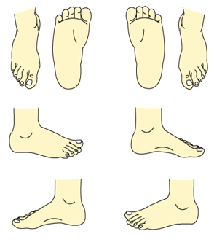         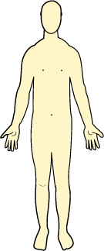       

|  |  |  |  |  |
| --- | --- | --- | --- | --- |
| **Date** | **Ulcer Number** | **Ulcer Location** | **Grade** (see toolkit) | **Signature** |
|  |  |  |  |  |
|  |  |  |  |  |
|  |  |  |  |  |
|  |  |  |  |  |
|  |  |  |  |  |
|  |  |  |  |  |

**Scottish Adapted European Pressure Ulcer Advisory Panel) EPUAP- Pressure Ulcer Grading Tool - 2014**

**GRADE 1** Intact skin with non-blanchable redness, usually over a bony prominence. Darker skin tones may not have visible blanching but the colour may differ from the surrounding skin. The area may be painful, firmer, softer warmer or cooler than the surrounding tissue.

**GRADE 2** Loss of epidermis/dermis presenting as a shallow open ulcer with red/pink wound bed without slough or bruising. May also present as a blister.

**GRADE 3** Subcutaneous fat may be visible but bone tendon or muscle is not visible of palpable.

Slough may present but does not obscure the depth of tissue loss. Often includes undermining or tunnelling.

**GRADE 4** Extensive destruction with exposed or palpable bone, tendon or muscle. Slough may be present but does not obscure the depth of tissue loss. Often includes undermining or tunnelling.

**DEEP TISSUE INJURY** Epidermis is intact but the area appears purple or maroon or is a blood filled blister over a dark wound bed. Over time the skin will degrade and develop into deeper tissue loss.