Guidance on databases and required approvals for research use
Contents
Scope and purpose of this document 1
1. Differences between study specific databases and ‘research databases’ 2
1.1 Study Specific Databases 2
1.2 Research Databases 2
1.3 Types of Databases not considered to be a Research Database 3
1.4 Data collection into databases for purposes of audit or service evaluation and improvement 3
2. Applying for ethical review of research databases 4
2.1 Approval for the Research Database team 4
2.2 Generic approval for external researchers 4
3.Selecting the appropriate study category in IRAS 5
4.The differences between a registry and a database 6
5. National Datasets and Trusted Research Environments (TREs) 7
5.1 National datasets 7
5.2 What are Trusted Research Environments (TREs)? 7
6.Useful links 9

Scope and purpose of this document
This document was prepared by the Research and Development (R&D) department at University Hospitals Bristol and Weston (UHBW). It is intended as a guide for understanding the difference between a database used for a specific study and a ‘Research Database’ and what approvals are needed. It also briefly covers their use in non-research projects. This document also touches on the term ‘Trusted Research Environment’ and provides a resource for researchers interested in data sets available for research use.

Differences between study specific databases and ‘research databases’

1.1 Study Specific Databases
Most clinical research studies (such as clinical trials, qualitative studies) will involve collection of data, and this will be stored in some kind of database (e.g., REDCAP). Details of the database, how the data will be collected, stored and analysed will be contained in the protocol for that particular study. The protocol should also detail what will happen to the data after the study has ended, how long it will be kept before being destroyed, and whether the data can be used for future research studies. If this is intended, then consent needs to be given by participants in the original study for their data to be used future research projects (and specified if this is to include audit or service evaluation). This should be made clear in consent forms and participant information sheets.
Such studies will have gained HRA and NHS REC approval for that study only. If the data is to be used in future research projects (with prospective consent), then each future research project will need its own approvals. Please refer to section 3 of this document for further guidance when selecting the appropriate IRAS study category for your project.

1.2 Research Databases
Data can be collected for future research projects without a specific hypothesis or research question in mind at the time the database is set up. Examples include those for rare disease, and ‘natural history’ studies, where information about people with a specific condition is collected over the long term, with the eventual aim that it will act as a resource for researchers to benefit patients in the future. Alternatively, you may have obtained REC/HRA approval for a specific study, and you now want to keep the data beyond the lifespan of your specific project.
- When setting up a research database you may decide to apply for NHS REC approval of the database. Please note REC approval is usually optional but it is advisable as it can make it easier for future use of the data including data release to other researchers and ensuring governance arrangements of appropriate storage. Please refer to section 2 below for further information on approval processes for research databases.

- As per the REC SOPs, “REC approval is required by law where the activities of a research database would include accessing or otherwise processing the identifiable data of patients or services users in England and Wales outside the normal care team without consent. This would require application to both the Confidentiality Advisory Group and a Research Ethics Committee under Section 251 of the NHS Act 2006 to set aside the common law duty of confidentiality owed by care professionals to their patients or clients.”
HRA approval is not required for research databases.

1.3 Types of Databases not considered to be a Research Database
The REC SOPs list some scenarios where a database is not considered a research database:
- Databases containing only aggregated rather than individual-level information;
- Databases holding contact information only, e.g., of participants in a specific project or potential participants who may be approached to take part in future research;
- Databases established to support one specific project only, e.g., a clinical trial database, or a registry established by a pharmaceutical company or device manufacturer for post-market surveillance of patients treated using a particular medicinal product or device;
- Databases holding information about research studies, e.g., clinical trial registers, or databases established by research regulators or governance bodies to support their functions;
- Databases held with biological samples as part of a research tissue bank.

1.4 Data collection into databases for purposes of audit or service evaluation and improvement
If data is collected and added to a database for clinical care, audit, or service evaluation purposes at a single Trust, this would not be considered a research database and HRA/REC review would not be required. However, if databases were created for purposes other than research, and there is now an intention to use that database for research purposes, please ensure you refer to all the sections of this document to check what you will be expected to do.

2. Applying for ethical review of research databases

Applicants should ensure that they select the appropriate option for a research database application in IRAS. The application should be made by the person with overall responsibility for the management of the Database, who will be regarded as the Data Controller. The application should be supported by a Data Custodian, who will be a senior person within the organisation responsible for the database. This should not be the applicant, and the Data Custodian needs to be independent of the research database team, and able to provide assurance that appropriate information governance is in place. For example, a consultant in a similar clinical field with knowledge of appropriate IG procedures.
Please refer to the REC SOPs for the typical issues that may come up in the REC review.
Scope of ethical approval

There are two different types of REC approvals that the investigator can obtain for a research database concerning who can manage/access the data.

2.1 Approval for the Research Database team

Where a favourable opinion is given, this will give ethical approval to the Research Database team to collect, store and use identifiable data for the purposes for which consent has been sought. These should be described in the REC application and will typically include activities such as data cleansing, linkage, anonymisation / pseudonymisation, audit and verification, as well as analysis in research studies conducted by researchers within the team. The Research Database team will normally have consent from data subjects to process their personal data, unless exceptionally approval from the HRA on the advice of the CAG is also obtained to process identifiable data without consent.

2.2 Generic approval for external researchers
Applicants may also seek generic approval to allow external researchers to receive non-identifiable data to undertake valuable scientific studies. Data sharing is encouraged in the interests of maximising the research potential of stored data, provided that adequate safeguards are in place to protect confidentiality. The REC may give generic approval extending to studies by external researcher’s subject to conditions (see paragraph 11.27 in REC SOP). If this generic approval is not in place all external researchers will be required to obtain REC approval for their individual projects for use of the data.
External researchers will generally not have consent to process personal data unless they are established collaborations and have been specifically covered in the terms of consent (in this case, they may be considered part of the Research Database team). Therefore, external researchers relying on generic approval must not receive data in identifiable form or be able to identify subjects through linkage with other databases. Where an external researcher requires access to identifiable data or further contact with data subjects to undertake a study, a further project-specific application should be made for ethical review.

Selecting the appropriate study category in IRAS

When a research project is added to IRAS, the researcher needs to select a category for their study. If data needs to be collected for a specific research project (where there will be no participant contact or observation other than to seek informed consent for use of data for research), the IRAS category that should be selected is ‘Study limited to working with data (specific project only)’. This category applies to specific research projects using data to investigate specific research question(s) described in a protocol. HRA Approval will be required for research projects collecting data for a specific research question. Where a favourable ethical opinion is given (if applicable), this will apply for the duration of this project only. Data collected will be saved in a form of a ‘database’, e.g., excel spreadsheet, RED Cap etc.
When this category is selected, the researcher will be asked whether REC review is required. If the researcher selects that their study is exempt from REC review, they will be asked whether the study falls into one of the following categories
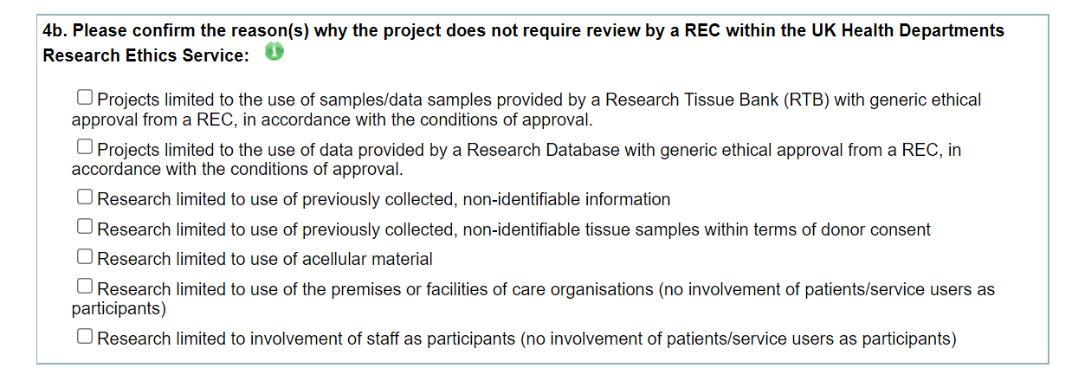
If the researcher wants to keep the study data in a database beyond the life of this specific project, or the researcher wants to collect data for future research use the database would be considered a ‘research database’ and guidance above in section 1 and 2 would apply. The appropriate category would need to be selected in IRAS as shown in the screenshot below.
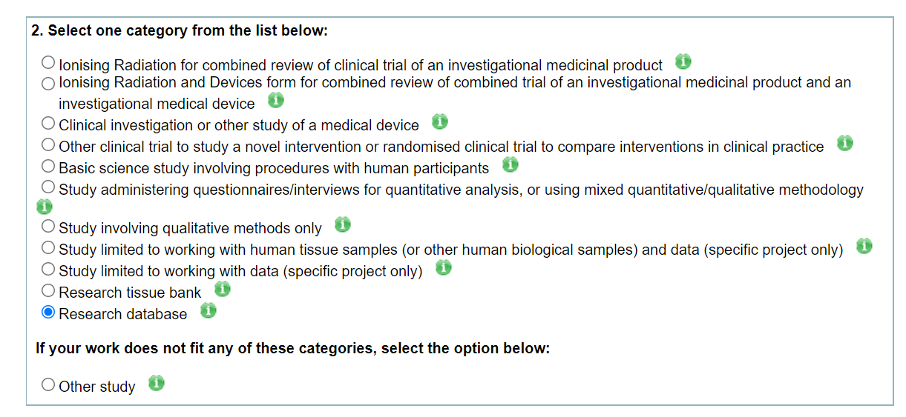

The differences between a registry and a database

These terms are often used interchangeably, however, there are clear differences between registries and databases. A research registry is a collection of information about individuals. There are different types of research registries; a) registries/clinical audits (not research projects) to evaluate outcomes for a population with a particular disease or condition and b) registries that hold the contact details of people interested in being research participants for future studies. As registries are not considered research projects, HRA Approval/REC review are not required.
As mentioned previously, research databases involve the collection of data which is stored for potential research use beyond the life of a specific project.
If you are interested in developing a registry, please contact the UHBW Clinical audit department to discuss your ideas with the appropriate member of staff. For research databases, please contact the UHBW R&D department if you have any questions.

5. National Datasets and Trusted Research Environments (TREs)

5.1 National datasets
There are many national datasets for particular conditions that have been set up in the UK and internationally. There are standard processes in place for individuals to request access to data for particular projects.
Examples of national datasets include:
- National Institute for Cardiovascular Outcomes Research (NICOR)
- NIHR Health Informatics Collaborative
- Clinical Record Interactive Search (CRIS) and the Dementia CRIS (D-CRIS)
- NHS Digital

These datasets normally have REC approval and have a governance structure that handles requests for the data. Most requests for data must be for specific studies that have their own HRA and REC approval, and there is often a charge for processing and release of data as well as contractual arrangements that need to be put in place.

5.2 What are Trusted Research Environments (TREs)?
The TRE service provides approved researchers from trusted organisations with secure access to health and care data. Researchers are given access to their approved data (in accordance with their Data Sharing Agreements), enabling them to collaborate, link data, share code and results within the same research projects.
The service provides a secure data platform with the analytical and statistical tools to support researchers in conducting their work. Their findings can then be exported safely, ensuring the formats and analyses are approved and sent to authorised users. Using this option saves time for the researchers as they do not need to wait for the Host organisation to provide reports containing the required pseudo anonymised/anonymised data for the research project.
For example, NHS Digital can provide researchers with:
- A transparent and secure access management process to make decisions on applications to bring data, tools and code into the environment. This transparency delivers assurance to patients and the public that any information inputs are safe and assessed at the point of entering the environment.
- A Safe Output Service that is robust, effective and transparent to third-party audit.

The Health Data Research Innovation Gateway enables researchers to find information about UK healthcare data sets that are available for research and directs you to the relevant data custodians to request access. The Health Data Research Innovation Gateway includes the Metadata Catalogue, which is a catalogue describing the data sets available for research. The site provides information for the following NHS Data providers:
- NHS Digital
- Public Health England (PHE)
- Clinical Practice Research Datalink (CRPD)
- Direct from NHS Care Organisations (NHS)
- Information Services Division (ISD)
- Secure Anonymised Information Linkage (SAIL)
- Honest Broker Service (HBS)

UHBW does not currently hold a TRE, however, UHBW is part of HDRUK. For further information about their services, please refer to their website.

Useful links

HRA/REC
https://www.hra.nhs.uk/about-us/committees-and-services/res-and-recs/research-ethics-committee-standard-operating-procedures/ (REC SOPs)
https://www.hra.nhs.uk/planning-and-improving-research/policies-standards-legislation/research-tissue-banks-and-research-databases/ (HRA- Further information about Research Databases)
https://www.myresearchproject.org.uk/help/hlpcollatedqsg-sieve.aspx#1309 (IRAS – Further information about selecting the appropriate category)

National Datasets and Trusted Research Environments
https://digital.nhs.uk/data-and-information/data-collections-and-data-sets/data-sets (NHS digital - National datasets available)
https://www.healthdatagateway.org/
https://digital.nhs.uk/coronavirus/coronavirus-data-services-updates/trusted-research-environment-service-for-england (Further information about TREs)

