Introduction

The Haematology Department at University Hospitals Bristol complies with ISO 15189:2012 “Medical laboratories: Requirements for quality and competence”. Standard 4.14.3 “Assessment of user feedback” states that the laboratory shall seek information relating to user perception as to whether the service has met the needs and requirements of users. This survey has been performed to comply with these standards, and in doing so, will bring to the attention of laboratory management areas where we could improve the Haematology Laboratory Sickle Cell and Thalassaemia Screening service.

The Sickle Cell and Thalassaemia Screening Laboratory User Satisfaction survey was carried out by University Hospitals Bristol NHSFT (UHB) between 9th July 2019 and 17th October 2019.

Objectives

The purpose of the survey was to assess the level of satisfaction of the Sickle Cell and Thalassaemia Screening Laboratory users by asking for responses to specific questions and statements. The information gained through this exercise enabled the laboratory management team to look at the service we provide and decide how to improve it to meet the needs and requirements of our users, as part of our commitment to continually improve quality.

Response to the Survey

This short survey was designed by the Lead Biomedical Scientist for the Screening Laboratory to elicit users’ views about the Laboratory service at University Hospitals Bristol NHSFT. Users of University Hospitals Bristol NHSFT Laboratory Services were encouraged to complete the online User Survey using Survey Monkey. The link to the survey was distributed to the Screening Midwives by the Community Midwifery Clerk.

In total, 5 responses to the survey were received, self-identified as coming from the following groups:
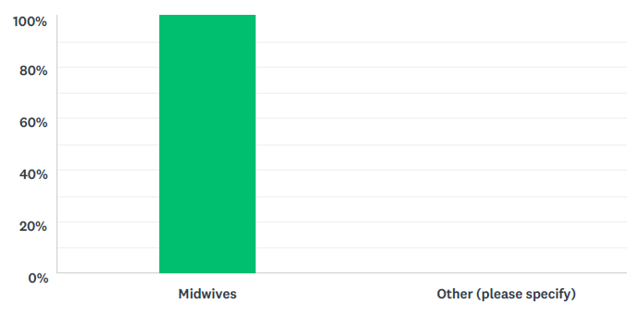

Role | Responses
Midwives | 5
Other | 0

Method Used

The Questionnaire

The questionnaire was comprised of the following:

- Users were asked to rate (from strongly agree to strongly disagree) the following statements about the service:

- “I can trust the laboratory to provide results/reports when I need them”
- “I am satisfied with the quality of professional advice that I receive from the laboratory”
- “I am satisfied with the quality of reports that I receive from the laboratory”
- “I am satisfied with the level of detail contained in the Family Origin Questionnaire (FOQ) request in ICE”
- “Professional advice is readily available from the laboratory when needed”
- “I am confident that urgent/unexpected results will be promptly communicated”
- “Local systems to transport specimens work well”
- “I would recommend the laboratory service to a colleague”

- Users were asked to respond to the following questions:

- How might the laboratory Sickle Cell and Thalassaemia screening service be improved?
- How might the specimen transport service be improved?
- How might the results delivery service be improved?

- The closing statement to users asked for any other comments they wish to make about the service provided by the Haematology laboratory at UHB. (This was an optional question).

The laboratory target for user satisfaction is that for each statement a satisfactory response of > 90% must be achieved. We have defined a satisfactory response as either Strongly Agree, Agree, or Neither Agree nor Disagree. Any results falling outside of this limit will require further investigation to see what appropriate actions are required to improve that aspect of the service

Results

The following graphs illustrate the results of the responses for each of the statements:

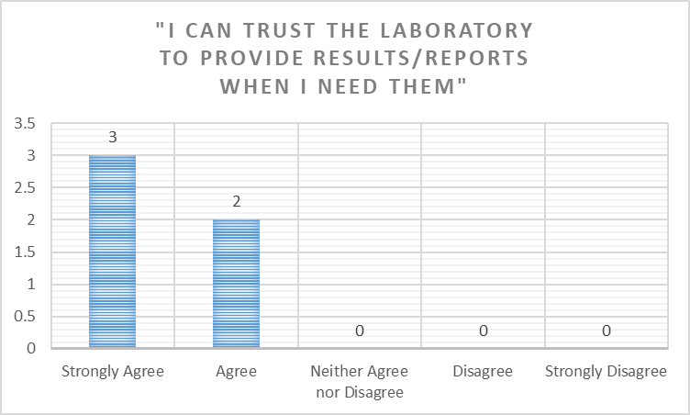

Answered: 5. Skipped: 0.

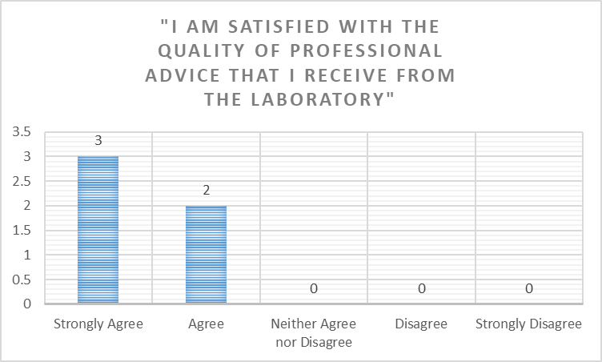

Answered: 5. Skipped: 0.

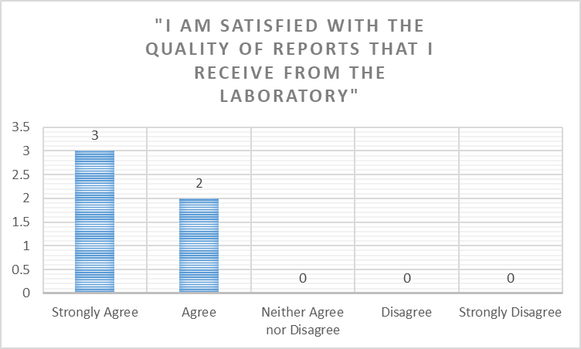

Answered: 5. Skipped: 0.

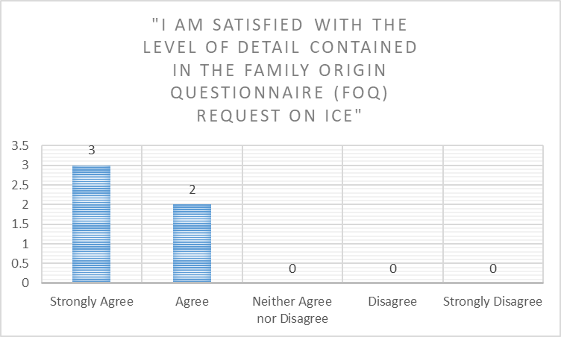

Answered: 5. Skipped: 0.

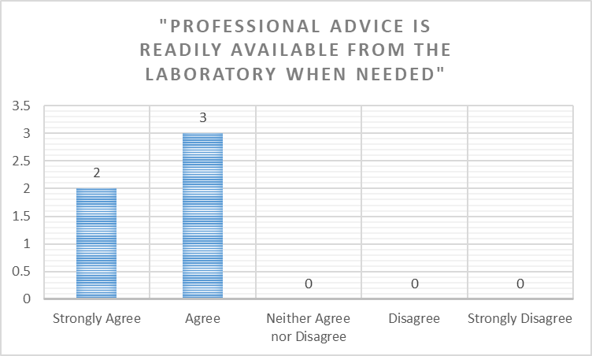

Answered: 5. Skipped: 0.

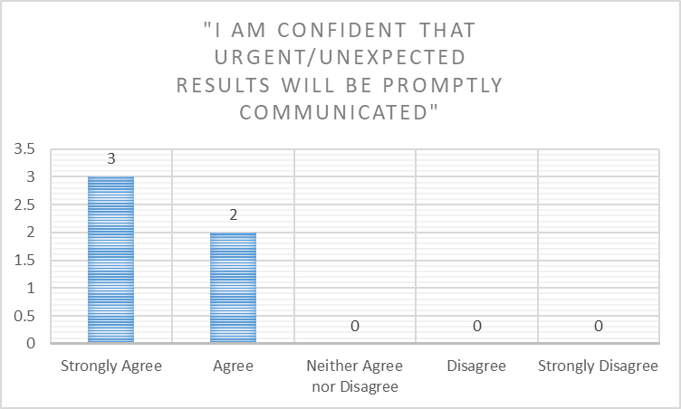

Answered: 5. Skipped: 0.

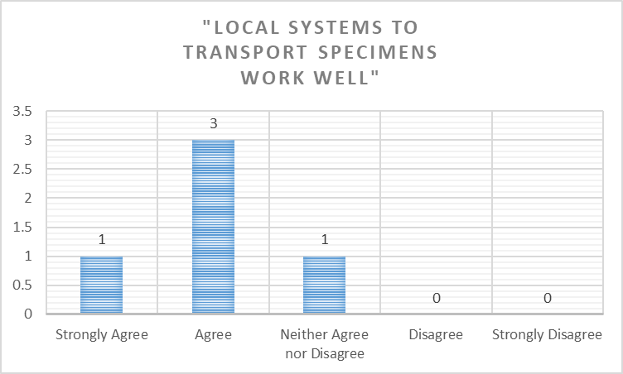

Answered: 5. Skipped: 0.

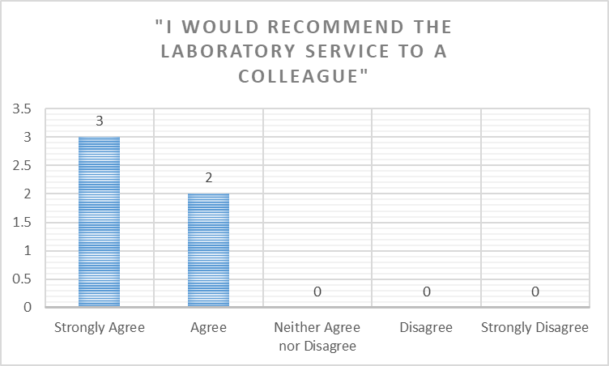

Answered: 5. Skipped: 0.

Summary Table of Percentage User Satisfaction

The laboratory target for user satisfaction is that for each statement a satisfactory response of > 90% must be achieved.

Statement | Percentage Satisfied (Strongly Agree to Neither Agree nor Disagree) | Percentage Dissatisfied  (Disagree to Strongly Disagree) | Don’t Know | Overall Percentage Satisfied (excluding “Don’t Know”)
“I can trust the laboratory to provide results/reports when I need them” | 100% | 0% | 0% | 100%
“I am satisfied with the quality of professional advice that I receive from the laboratory” | 100% | 0% | 0% | 100%
“I am satisfied with the quality of reports that I receive from the laboratory” | 100% | 0% | 0% | 100%
“I am satisfied with the level of detail contained in the Family Origin Questionnaire (FOQ) request in ICE” | 100% | 0% | 0% | 100%
“Professional advice is readily available from the laboratory when needed” | 100% | 0% | 0% | 100%
“I am confident that urgent/unexpected results will be promptly communicated” | 100% | 0% | 0% | 100%
“Local systems to transport specimens work well” | 100% | 0% | 0% | 100%
“I would recommend the laboratory service to a colleague” | 100% | 0% | 0% | 100%

Users responded to the questions as follows:

How might the laboratory Sickle Cell and Thalassaemia screening service be improved?

3 Skipped.
2 Responses:
- It is satisfactory
- I feel it does every thing to its best level already

How might the specimen transport service be improved?

1 Skipped.
4 Responses:
- More pick ups from community especially weekends.
- More frequent collections
- More pick ups at the week end is needed especially from south Bristol hospital.
- More regular transport over the weekends

How might the results delivery service be improved?

3 Skipped.
2 Responses:
- We look then up on ICE and rarely have a problem.
- More regular

Please add any other comments you wish to make about the service provided by the Haematology laboratory at UHB.

- Skipped.
1 Response:
- I don't feel its always appreciated just how difficult it can be to obtain a sample

Laboratory Responses and Suggested Actions

How might the laboratory Sickle Cell and Thalassaemia screening service be improved?

Comment | Laboratory Response/Action
It is satisfactory | Thank you
I feel it does every thing to its best level already | Thank you

How might the specimen transport service be improved?

Comment | Laboratory Response/Action
More pick ups from community especially weekends. | The laboratory is currently in discussions with the Trust Transport Manager to see what additional services can be accommodated based on projected work patterns.
More frequent collections
More pick ups at the week end is needed especially from south Bristol hospital.
More regular transport over the weekends

How might the results delivery service be improved?

Comment | Laboratory Response/Action
We look then up on ICE and rarely have a problem. | That is good to hear.
More regular | The laboratory consistently reports >99% of screening results within 3 working days. Please contact the laboratory if you have specific concerns.

Please add any other comments you wish to make about the service provided by the Haematology laboratory at UHB.

Comment | Laboratory Response/Action
I don't feel its always appreciated just how difficult it can be to obtain a sample | Sample quality and volume are crucial for achieving accurate and precise results. Please contact the laboratory if you have specific concerns you wish to raise.

Conclusion and Summary

The Sickle Cell and Thalassaemia Screening user survey reflects the high quality service provided by Haematology laboratory at University Hospitals Bristol NHS Foundation Trust.

Using our target satisfaction criteria of >90% satisfactory response, it is clear that we continue to meet the needs of our users in the majority areas. One area highlighted for further investigation is Specimen Transport and there are discussions taking place with the Trust Transport Manager to see where improvement measures can be accommodated.

We appreciate the time taken by our users to complete the survey. We continue to seek other means of feedback where possible. We are continually reviewing the service we provide to our users and continually seeking to improve wherever possible, despite the growing financial challenge. We will take the feedback we have gained from this survey and use it to focus our efforts.

We are grateful to all those who took the time to respond to our User Survey and we hope that we will be able to address the issues you have raised so that filling in the questionnaire was time well spent. We will be repeating the Sickle Cell and Thalassaemia Screening User survey in 2020, to re-assess our performance and monitor any improvement.

If you want to feedback on the Action plan, or you did not get an opportunity to complete the User Survey and want to provide feedback regarding our services please contact the Blood Sciences Automation Laboratory Manager and Quality Manager Mark Nicholas Mark.Nicholas@UHBristol.nhs.uk who will be happy to respond to any feedback.

If you prefer, please contact the Head of Service Elizabeth Worsam Elizabeth.worsam@UHBristol.nhs.uk

