Introduction

The Clinical Biochemistry and Haematology Department complies with ISO 15189:2012 “Medical laboratories: Requirements for quality and competence”. Standard 4.14.3 “Assessment of user feedback” states that the laboratory shall seek information relating to user perception as to whether the service has met the needs and requirements of users. This survey has been performed to comply with these standards, and in doing so, will bring to the attention of laboratory management areas where we could improve the Haematology and Clinical Biochemistry service.

The GP User Satisfaction survey was carried out by Blood Sciences Laboratory at University Hospitals Bristol NHSFT (UHB) between 9th July 2019 and 17th October 2019.

Objectives

The purpose of the survey was to assess the level of satisfaction of the GP users with the overall Laboratory Service by responding to specific questions and statements. The information gained through this exercise enabled the laboratory management team to look at the service we provide and decide how to improve it to meet the needs and requirements of our users, as part of our commitment to continually improve quality.

Response to the Survey

This short survey was designed by the Clinical Lead for Laboratory Medicine and the Quality Manager’s for Haematology and Clinical Biochemistry to elicit GP users’ views about the Laboratory service at University Hospitals Bristol NHSFT. Users of University Hospitals Bristol NHSFT Laboratory Services were encouraged to complete the online User Survey using Survey Monkey. This information was relayed to the GP users of the Laboratory Service via the BNSSG weekly newsletter. The survey was promoted within the newsletter for four weeks. An email, containing survey information and a link to the user survey, was also sent to the email distribution list of Practice Managers by the Trust’s GP Liaison service.

19 responses were received in total, self-identified as coming from the following groups:
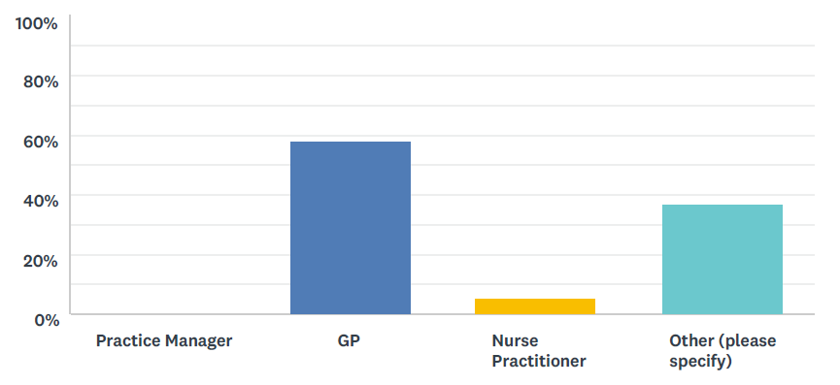

Role | Responses
GP | 11
Nurse Practitioner | 1
(Other) – Practice Nurse | 4
(Other) – HCA | 1
(Other) – Treatment room | 1
(Other) – Treatment Room HCA | 1

Method Used

The Questionnaire

The questionnaire was comprised of the following:

- Users were asked to rate (from strongly agree to strongly disagree) the following statements about the service:

- “I can trust the laboratory to provide results/reports when I need them”
- “I am satisfied with the quality of professional advice that I receive from the laboratory”
- “Professional advice is readily available from the laboratory when needed”
- “I am confident that urgent/unexpected results will be promptly communicated”
- “Local systems to transport specimens work well”
- “The level of out of hours service meets my needs”
- “I would recommend the laboratory service to a colleague”

- Users were asked to respond to the following questions:

- How might the Biochemistry service be improved?
- How might the Haematology and Blood Transfusion service be improved?
- How might the Specimen Transport service be improved?
- How might the Results Delivery service be improved?
- How might the provision of advice on test use and interpretation be improved?

- The closing statement to users asked for any other comments they wish to make about the service provided by Laboratory Medicine. (This was an optional question).

The laboratory target for user satisfaction is that for each statement a satisfactory response of > 90% must be achieved. We have defined a satisfactory response as either Strongly Agree, Agree, or Neither Agree nor Disagree. Any results falling outside of this limit will require further investigation to see what appropriate actions are required to improve that aspect of the service

Results

The following graphs illustrate the results of the responses for each of the statements:

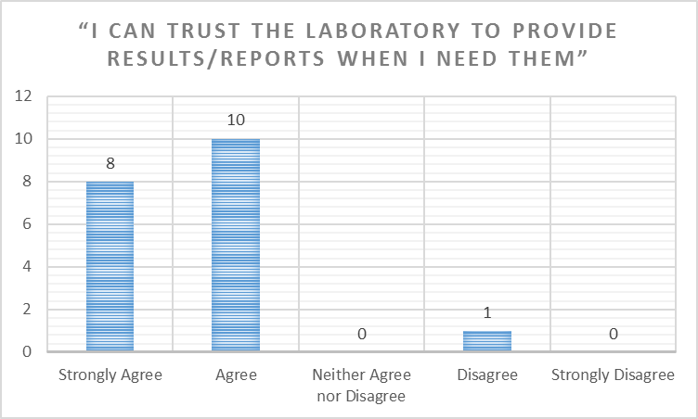

Responses - Answered: 19. Skipped: 0.

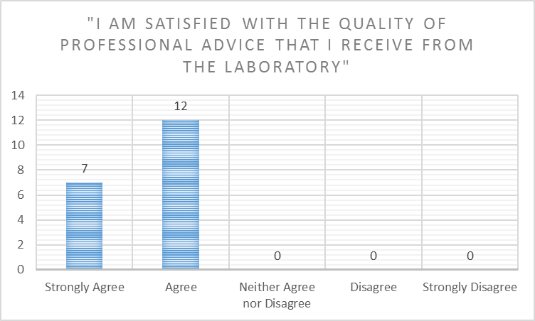

Answered: 19. Skipped: 0.

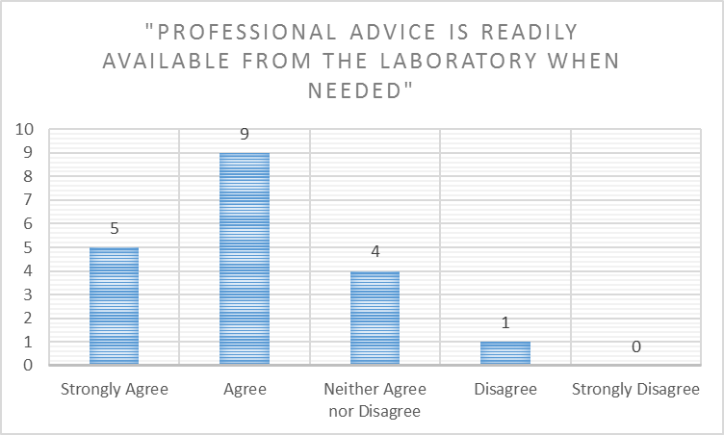

Answered: 19. Skipped: 0.

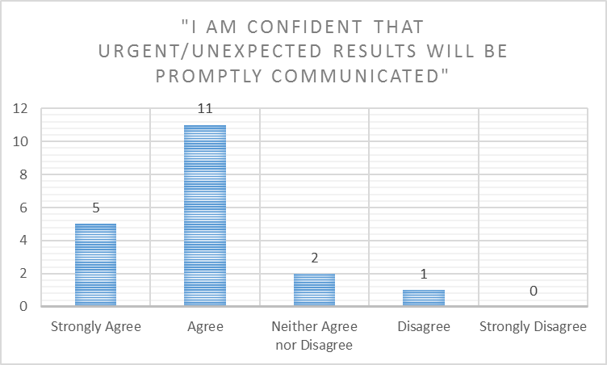

Answered: 19. Skipped: 0.

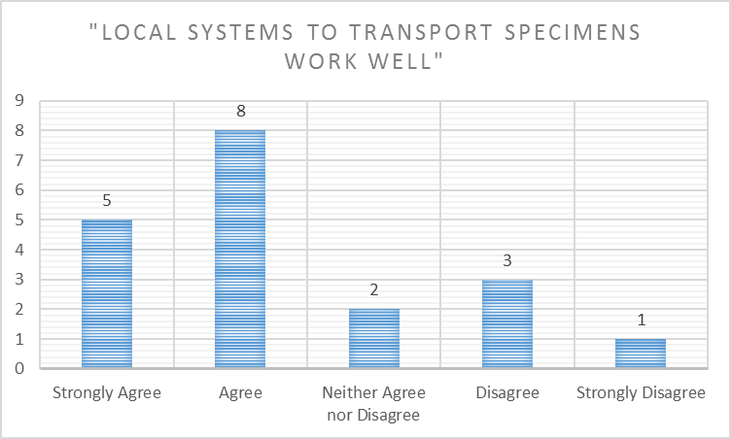

Answered: 19. Skipped: 0.

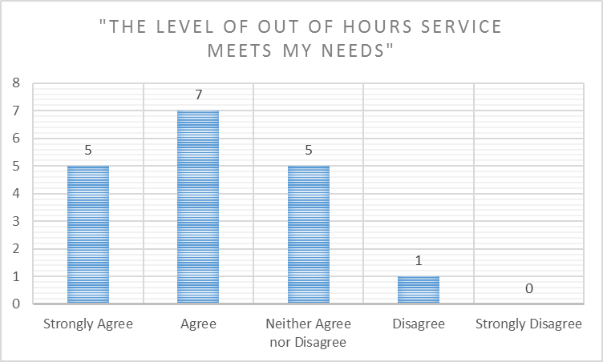

Answered: 18. Skipped: 1.

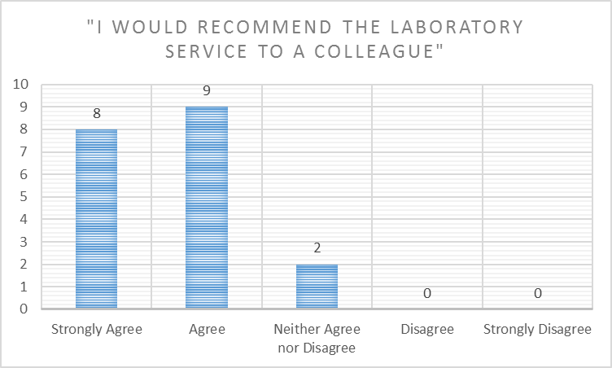

Answered: 19. Skipped: 0.

Summary Table of Percentage User Satisfaction

The laboratory target for user satisfaction is that for each statement a satisfactory response of > 90% must be achieved.

Statement | Percentage Satisfied (Strongly Agree to Neither Agree nor Disagree) | Percentage Dissatisfied  (Disagree to Strongly Disagree) | Satisfactory Response of >90% Achieved?
“I can trust the laboratory to provide results/reports when I need them” | 94.74% | 5.26% | Yes
“I am satisfied with the quality of professional advice that I receive from the laboratory” | 100% | 0% | Yes
“Professional advice is readily available from the laboratory when needed” | 94.74% | 5.26% | Yes
“I am confident that urgent/unexpected results will be promptly communicated” | 94.74% | 5.26% | Yes
“Local systems to transport specimens work well” | 78.95% | 21.05% | No
“The level of out of hours service meets my needs” | 94.44% | 5.56% | Yes
“I would recommend the laboratory service to a colleague” | 100% | 0% | Yes

Users responded to the questions as follows:

How might the Biochemistry service be improved?

9 Skipped.
10 Responses:
- Better communication, getting through to Lab staff very difficult, then being passed onto Biochemist etc. is difficult. Better transport communication, need a Saturday service.
- A one-stop, one sample testing system For non-invasive liver screening, where GPs take a blood sample and the lab follows a pathway to work out what action the patient needs to take (I heard a programme on the radio about another hospital which does this-I'm afraid to say that I've forgotten which one!). This would be a really useful service.
- I think you provide a really good service meeting my needs as a GP.
- Any chance for a twice daily blood pickup?
- Continue advice and guidance email service.
- Works well, maybe give out direct dial numbers for getting clinical advice.
- I have always had good relationships and communications with this service.
- Relevant and timely information when changes are introduced, some consultation on changes would also be good.
- Making more clear which results will be communicated to GPs for urgent action.
- Out of hours reflect in hours support.

How might the Haematology and Blood Transfusion service be improved?

11 Skipped.
8 Responses:
- The service is prompt and I usually receive the results on the same day as the test.
- Continue to get results out as soon as able, thanks!
- Protect A&G service for GPs.
- It’s ok.
- Cannot think of any ways.
- Making more clear which results will be communicated to GPs for urgent action.
- Out of hours reflect in hours support.
- Stop sending duplicate INR results: we only need the one with the dosing on. It's a pain getting it twice.

How might the Specimen Transport service be improved?

8 Skipped.
11 Responses:
- Better transport communication, need a Saturday service.
- Make it easier to arrange collections for weekend improved access clinics.
- Flexibility to a later collection would be convenient and collection on Saturdays.
- Ours is good, currently 1pm, would love to have a later pick up or twice daily pick up.
- Late collection pin Friday afternoon or Sat am.
- It’s ok.
- Cannot think of any ways.
- Collection time too early on a Friday to meet the potential for results needing to be processed for the weekend.
- Accommodate the fact that we are opening later and on Friday afternoons. I can’t take a blood sample after 2pm on a Friday which restricts the service can provide in the surgery.
- Seems to work well.
- Ok.

How might the Results Delivery service be improved?

- Skipped.
10 Responses:
- It is sometimes random when results are deliver via the computer, especially a Friday afternoon evening.
- Stop the multiple separate messages for some tests like INR and MSU.
- I am satisfied that I receive results promptly.
- Some tests don't flag up abnormal results - e.g.: PSA, abnormal flags helps.
- Ensure abnormal results phoned through.
- It’s ok.
- Cannot think of any ways.
- As above - I do not know your thresholds for flagging up abnormal results.
- Joined up with other local hospitals- one platform please.
- See above for INR results.

How might the provision of advice on test use and interpretation be improved?

10 Skipped.
9 Responses:
- Have a list of lab contact numbers for haematology and anticoagulation clinic on remedy to make it easy to find the telephone number you need to get advice, like there is for biochemistry.
- A list of the contact numbers of all the consultants/phone numbers we can use would be super helpful and appreciated.
- Many additional comments are very helpful, e.g.: thyroid guidance, or rarely used tests requested by specialists.
- More information in yellow box on ICE.
- Happy to get more written feedback re results.
- Incorporate phone numbers into results?
- Advice number made available.
- Seems to work very well every time I have needed.
- Ok at the moment.

Any other comments you wish to make about the service provided by Laboratory medicine?

15 Skipped.
4 Responses:
- Thank you- I think you all do a really good job.
- Provide direct dial clinical advice phone numbers.
- Joined up platform all hospitals.
- Generally great, thanks.

Laboratory Responses and Suggested Actions

How might the Biochemistry service be improved?

Comment | Laboratory Response/Action
Better communication, getting through to Lab staff very difficult, then being passed onto Biochemist etc. is difficult. Better transport communication, need a Saturday service. | Direct telephone line numbers are listed on the Trust website but we will look into making these more accessible.  We are not currently resourced to provide a Saturday specimen transport but this continues under review.
A one-stop, one sample testing system For non-invasive liver screening, where GPs take a blood sample and the lab follows a pathway to work out what action the patient needs to take (I heard a programme on the radio about another hospital which does this-I'm afraid to say that I've forgotten which one!). This would be a really useful service. | We provide decision support and liver screen profiles via ICE, and where appropriate, interpretation of abnormal results. It is not currently feasible for us to perform reflex testing based on initial abnormal results or other findings although we would be interested in reviewing good practice from elsewhere.
I think you provide a really good service meeting my needs as a GP. | Thank you.
Any chance for a twice daily blood pickup? | Twice daily transport is provided to some practices. Please contact the Head of Service to discuss your needs.
Continue advice and guidance email service. | This service is still in place. It is good that it is perceived to be of value.
Works well, maybe give out direct dial numbers for getting clinical advice. | Direct telephone line numbers are listed on the Trust website but we will look into making these more accessible.
I have always had good relationships and communications with this service. | Thank you.
Relevant and timely information when changes are introduced, some consultation on changes would also be good. | We do aim to provide relevant and timely information when relevant, and consult where possible, although it is not possible to consult directly with all users at all times.
Making more clear which results will be communicated to GPs for urgent action. | We adhere to Royal College of Pathologists Guidance ‘The communication of critical and unexpected pathology results’ and have a definitive departmental policy. Further information can be provided on request.
Out of hours reflect in hours support. | The laboratory service is available, to support urgent and emergency care, 24/7. Clinical advice is also available at all times via the on call clinical biochemist.

How might the Haematology and Blood Transfusion service be improved?

Comment | Laboratory Response/Action
The service is prompt and I usually receive the results on the same day as the test. | Thank you.
Continue to get results out as soon as able, thanks! | Thank you.
Protect A&G service for GPs. | Advice and guidance is available 24/7 via the on call clinical biochemist and Haematology registrar.
It’s ok. | Thank you. We aim to provide an excellent service.
Cannot think of any ways. | Please contact us at any time if you wish to discuss any issues relating to the service.
Making more clear which results will be communicated to GPs for urgent action. | We adhere to Royal College of Pathologists Guidance ‘The communication of critical and unexpected pathology results’ and have a definitive departmental policy. Further information can be provided on request.
Out of hours reflect in hours support. | The laboratory service is available, to support urgent and emergency care, 24/7. Clinical advice is available at all times via the on call Haematology registrar.
Stop sending duplicate INR results: we only need the one with the dosing on. It's a pain getting it twice. | The workflow for INR requests is performed in two stages; the production of the INR result, and the warfarin dosing of the patient based on the INR result.  Our IT system rules are currently set to release the results once they have been validated. Work is currently being done to review our rule base to make the release of results as efficient as possible.

How might the Specimen Transport service be improved?

Comment | Laboratory Response/Action
Better transport communication, need a Saturday service. | The laboratory is currently in discussions with the Trust Transport Manager to see what additional services can be accommodated based on projected work patterns.
Make it easier to arrange collections for weekend improved access clinics. | As above.
Flexibility to a later collection would be convenient and collection on Saturdays. | As above.
Ours is good, currently 1pm, would love to have a later pick up or twice daily pick up. | As above.
Late collection pin Friday afternoon or Sat am. | As above.
It’s ok. | Thank you. We aim to provide an excellent service.
Cannot think of any ways. | Please contact us at any time if you wish to discuss any issues relating to the service.
Collection time too early on a Friday to meet the potential for results needing to be processed for the weekend. | As above.
Accommodate the fact that we are opening later and on Friday afternoons. I can’t take a blood sample after 2pm on a Friday which restricts the service can provide in the surgery. | As above.
Seems to work well. | Thank you.
Ok. | Thank you. We aim to provide an excellent service.

How might the Results Delivery service be improved?

Comment | Laboratory Response/Action
It is sometimes random when results are delivered via the computer, especially a Friday afternoon evening. | Results are released electronically as soon as they are available, rather than in timed batches. Because this is a busy service, samples that are received later in the day may not be reported until the evening.
Stop the multiple separate messages for some tests like INR and MSU. | Our IT system rules are currently set to release the results once they have been validated. Work is currently being done to review our rule base to make the release of results as efficient as possible.
I am satisfied that I receive results promptly. | This is our aim. Significantly abnormal result are phoned directly to the practice.
Some tests don't flag up abnormal results - e.g.: PSA, abnormal flags helps. | For some tests, where interpretation depends on the clinical context, or there is not a relevant upper or lower reference limit, it is not possible to add abnormal flags. For some tests, like PSA, we provide additional decision support to aid interpretation.
Ensure abnormal results phoned through. | We phone critically abnormal results. For lesser abnormalities there is a balance between the benefits of phoning and the disruption of doing so both at the practice and in terms of other work waiting to be processed in the laboratory.
It’s ok. | Thank you. We aim to provide an excellent service.
Cannot think of any ways. | Please contact us at any time if you wish to discuss any issues relating to the service.
As above - I do not know your thresholds for flagging up abnormal results. | We adhere to Royal College of Pathologists Guidance ‘The communication of critical and unexpected pathology results’ and have a definitive departmental policy. Further information can be provided if you would like to contact us.
Joined up with other local hospitals- one platform please. | This may occur in the future but we cannot currently link each local laboratory to a single order communications platform.
See above for INR results. | See above for INR response.

How might the provision of advice on test use and interpretation be improved?

Comment | Laboratory Response/Action
Have a list of lab contact numbers for haematology and anticoagulation clinic on remedy to make it easy to find the telephone number you need to get advice, like there is for biochemistry. | The Haematology department has recently reviewed and updated its list of laboratory contact numbers on the Trust website.
A list of the contact numbers of all the consultants/phone numbers we can use would be super helpful and appreciated. | Direct telephone line numbers are listed on the Trust website but we will look into making these more accessible.
Many additional comments are very helpful, e.g.: thyroid guidance, or rarely used tests requested by specialists. | Added value of this nature is an important part of our service.
More information in yellow box on ICE. | Information provided on ICE is continually reviewed and we would be happy to receive specific suggestions.
Happy to get more written feedback re results. | Our duty clinical biochemists provide written interpretation of results. It is good to know that it is appreciated and we aim to provide as much interpretation as feasible in the context of the clinical information available to us.
Incorporate phone numbers into results? | Phone numbers are available on our website and a few of our standard clinical results comments but to provide this information more widely would probably clutter reports too much.
Advice number made available. | Direct telephone line numbers are listed on the Trust website but we will look into making these more accessible
Seems to work very well every time I have needed. | Good.
Ok at the moment. | Thank you. We aim to provide an excellent service.

Any other comments you wish to make about the service provided by Laboratory medicine?

Comment | Laboratory Response/Action
Thank you- I think you all do a really good job. | Thank you. This is good to know.
Provide direct dial clinical advice phone numbers. | Direct telephone line numbers are listed on the Trust website but we will look into making these more accessible
Joined up platform all hospitals. | This may occur in the future but we cannot currently link each local laboratory to a single order communications platform.
Generally great, thanks. | Thank you.

Conclusion and Summary

The GP user survey results reflect the high quality service provided by the Clinical Biochemistry and Haematology laboratories at University Hospitals Bristol NHS Foundation Trust.

Using our target satisfaction criteria of >90% satisfactory response, it is clear that we continue to meet the needs of our users in the majority areas. One area highlighted for further investigation is Specimen Transport and there are discussions taking place with the Trust Transport Manager to see where improvement measures can be accommodated.

We appreciate the time taken by our users to complete the survey. We continue to seek other means of feedback where possible. We are continually reviewing the service we provide to our users and continually seeking to improve wherever possible, despite the growing financial challenge. We will take the feedback we have gained from this survey and use it to focus our efforts.

We are grateful to all those who took the time to respond to our User Survey and we hope that we will be able to address the issues you have raised so that filling in the questionnaire was time well spent. We will be repeating the GP User survey in 2021, to re-assess our performance and monitor any improvement.

If you want to feedback on the Action plan, or you did not get an opportunity to complete the User Survey and want to provide feedback regarding our services please contact our Quality Management Team, Carolyn Perry Carolyn.Perry@UHBristol.nhs.uk and Mark Nicholas Mark.Nicholas@UHBristol.nhs.uk who will be happy to respond to any feedback.

If you prefer, please contact the Head of Service Elizabeth Worsam Elizabeth.worsam@UHBristol.nhs.uk.

