Introduction

The Haematology Department at University Hospitals Bristol complies with ISO 15189:2012 “Medical laboratories: Requirements for quality and competence”. Standard 4.14.3 “Assessment of user feedback” states that the laboratory shall seek information relating to user perception as to whether the service has met the needs and requirements of users. This survey has been performed to comply with these standards, and in doing so, will bring to the attention of laboratory management areas where we could improve the Haematology Laboratory Sickle Cell and Thalassaemia Screening service.

The Sickle Cell and Thalassaemia Screening Laboratory User Satisfaction survey was carried out by University Hospitals Bristol NHSFT (UHB) between 5th September 2018 and 10th October 2018.

Objectives

The purpose of the survey was to assess the level of satisfaction of the Sickle Cell and Thalassaemia Screening Laboratory users by asking for responses to specific questions and statements. The information gained through this exercise enabled the laboratory management team to look at the service we provide and decide how to improve it to meet the needs and requirements of our users, as part of our commitment to continually improve quality.

Response to the Survey

This short survey was designed by the Lead Biomedical Scientist for the Screening Laboratory to elicit users’ views about the Laboratory service at University Hospitals Bristol NHSFT. Users of University Hospitals Bristol NHSFT Laboratory Services were encouraged to complete the online User Survey using Survey Monkey. The link to the survey was distributed to the Screening Midwives by the Community Midwifery Clerk.

In total, 16 responses to the survey were received, self-identified as coming from the following groups:
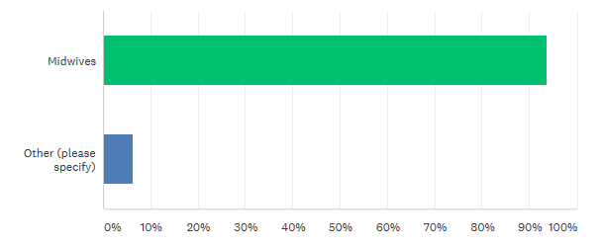

Role | Responses
Midwives | 15
Other (maternity support worker) | 1

Method Used

The Questionnaire

The questionnaire was comprised of the following:

- Users were asked to rate (from strongly agree to strongly disagree) the following statements about the service:

- “I can trust the laboratory to provide results/reports when I need them”
- “I am satisfied with the quality of professional advice that I receive from the laboratory”
- “I am satisfied with the quality of reports that I receive from the laboratory”
- “I am satisfied with the level of detail contained in the Family Origin Questionnaire (FOQ) request in ICE”
- “Professional advice is readily available from the laboratory when needed”
- “I am confident that urgent/unexpected results will be promptly communicated”
- “Local systems to transport specimens work well”
- “I would recommend the laboratory service to a colleague”

- Users were asked to respond to the following questions:

- How might the laboratory Sickle Cell and Thalassaemia screening service be improved?
- How might the specimen transport service be improved?
- How might the results delivery service be improved?

- The closing statement to users asked for any other comments they wish to make about the service provided by the Haematology laboratory at UHB. (This was an optional question).

The laboratory target for user satisfaction is that for each statement a satisfactory response of > 90% must be achieved. We have defined a satisfactory response as either Strongly Agree, Agree, or Neither Agree nor Disagree. Any results falling outside of this limit will require further investigation to see what appropriate actions are required to improve that aspect of the service

Results

The following graphs illustrate the results of the responses for each of the statements:

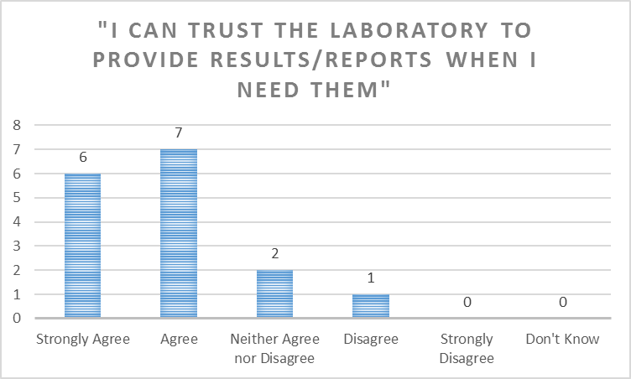

Answered: 16. Skipped: 0.

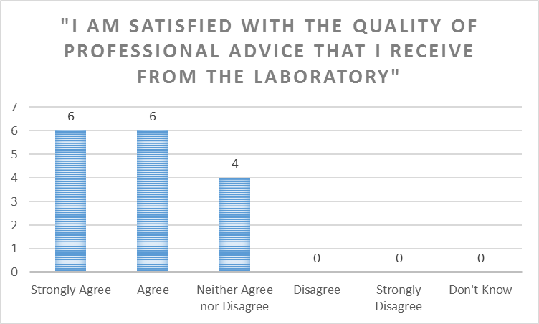

Answered: 16. Skipped: 0.

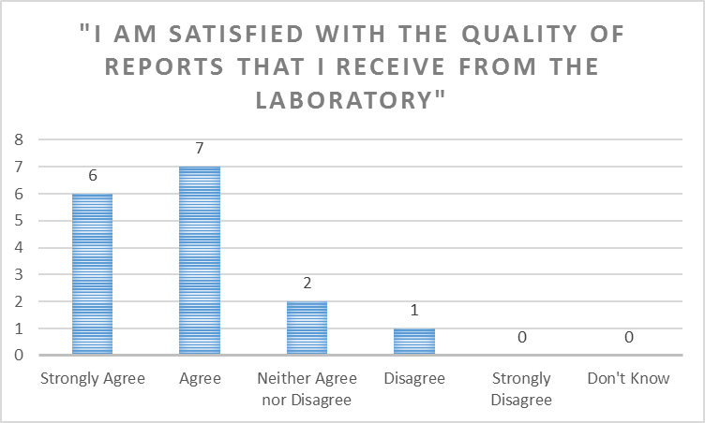

Answered: 16. Skipped: 0.

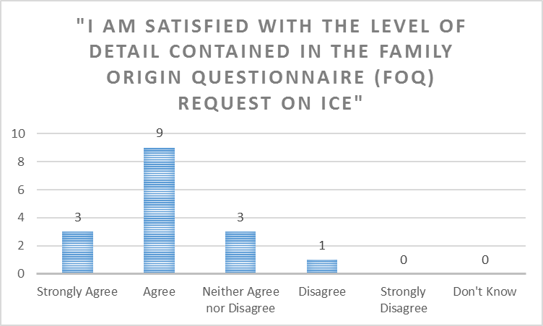

Answered: 16. Skipped: 0.

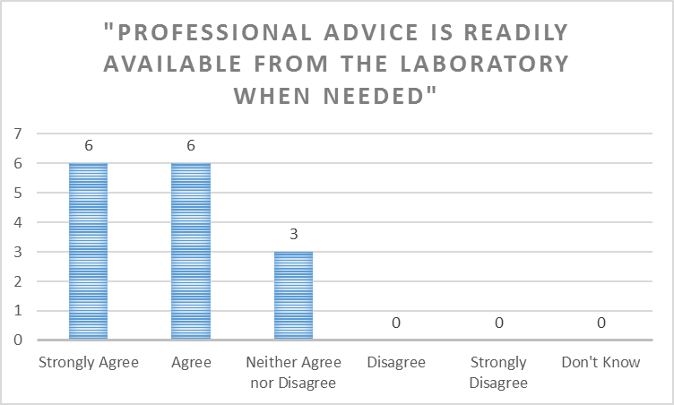

Answered: 15. Skipped: 1.

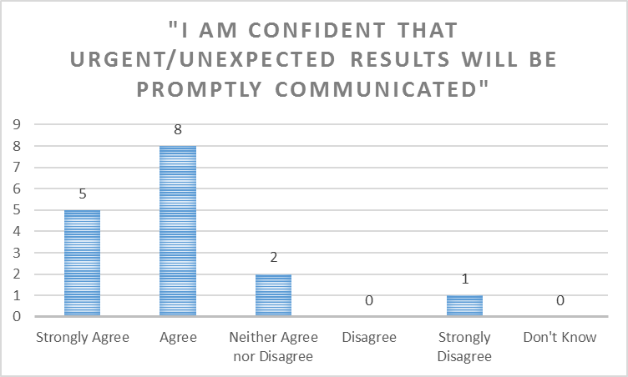

Answered: 16. Skipped: 0.

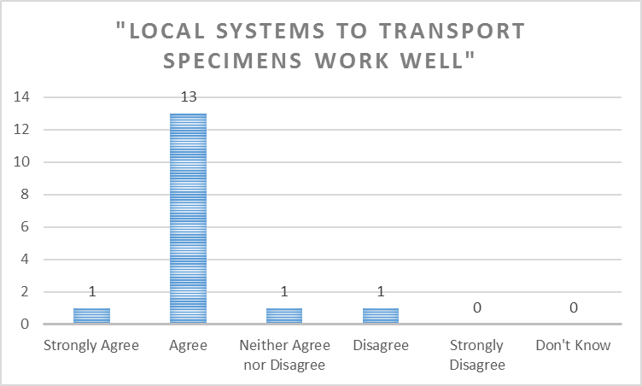

Answered: 16. Skipped: 0.

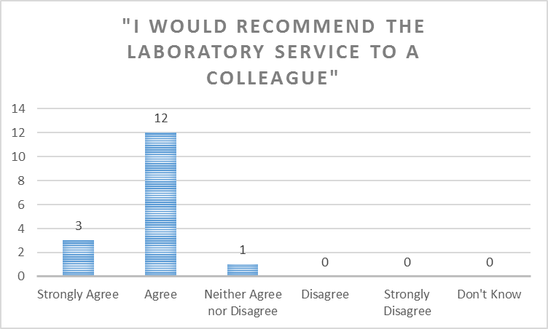

Answered: 16. Skipped: 0.

Summary Table of Percentage User Satisfaction

The laboratory target for user satisfaction is that for each statement a satisfactory response of > 90% must be achieved.

Statement | Percentage Satisfied (Strongly Agree to Neither Agree nor Disagree) | Percentage Dissatisfied  (Disagree to Strongly Disagree) | Don’t Know | Overall Percentage Satisfied (excluding “Don’t Know”)
“I can trust the laboratory to provide results/reports when I need them” | 93.75% | 6.25% | 0.0% | 93.75%
“I am satisfied with the quality of professional advice that I receive from the laboratory” | 100% | 0.0% | 0.0% | 100%
“I am satisfied with the quality of reports that I receive from the laboratory” | 93.75% | 6.25% | 0.0% | 93.75%
“I am satisfied with the level of detail contained in the Family Origin Questionnaire (FOQ) request in ICE” | 93.75% | 6.25% | 0.0% | 93.75%
“Professional advice is readily available from the laboratory when needed” | 100% | 0.0% | 0.0% | 100%
“I am confident that urgent/unexpected results will be promptly communicated” | 93.75% | 6.25% | 0.0% | 93.75%
“Local systems to transport specimens work well” | 93.75% | 6.25% | 0.0% | 93.75%
“I would recommend the laboratory service to a colleague” | 100% | 0.0% | 0.0% | 100%

Users responded to the questions as follows:

How might the laboratory Sickle Cell and Thalassaemia screening service be improved?

9 Skipped.
7 Responses:
- Unsure
- The on line order could be more user friendly, it could flag up obvious answers like uk, rather than having to scroll through to find.
- If you miss a bit on the form you have to fill the whole form in again that takes time
- No improvement needed
- We have experienced transport problems -where samples haven’t arrived.
- It works well in general I think the only improvement would be if we received a phone call if partner screening is required. We generally find out ourselves or we are alerted by the antenatal screening midwives
- It is not always possible to get partners in to be tested, quickly. but the blood labs system works well

How might the specimen transport service be improved?

8 Skipped.
8 Responses:
- It has been improved as Amelia Nutt clinic now has an afternoon collection when until recently only a morning collection.
- Its fine
- Run more frequent services in the week and especially at a weekend when there is only one collection at 8.30am as we work long days and complete bookings on the weekend
- More regular transports from community bases
- More collections
- More regular, especially Friday afternoons
- Offer more frequent collections and later ones as the last one is 15.00
- More pick ups

How might the results delivery service be improved?

12 Skipped.
4 Responses:
- We do not reliably get sent ALL results through post. We get some. Also some are more than a month old when we receive them.
- No problems
- Reports reaching midwives by 16/40
- Not an issue in general

Please add any other comments you wish to make about the service provided by the Haematology laboratory at UHB.

- Skipped.
4 Responses:
- The Lab staff are generally very helpful if we ring to discuss something. Regarding SBR results, I personally have been pleased with the service and staff have rung me with results if I put my mobile number on the request.
- The wider service does not always phone through unexpected results
- None
- I have always found the team available and supportive when contacted

Laboratory Responses and Suggested Actions

How might the laboratory Sickle Cell and Thalassaemia screening service be improved?

Comment | Laboratory Response/Action
Unsure
The on line order could be more user friendly, it could flag up obvious answers like uk, rather than having to scroll through to find. | The ICE OrderComms system has been designed to mirror the paper version of the Family Origin Questionnaire to reduce the risk of data entry errors.
If you miss a bit on the form you have to fill the whole form in again that takes time | Unfortunately the ICE OrderComms system will not allow for a ‘Back’ button to be built in to the FOQ pages. The request will need to be restarted to ensure all of the appropriate information is included.
No improvement needed
We have experienced transport problems -where samples haven’t arrived. | Please report any such incidents to us as they occur so that we can investigate.
It works well in general I think the only improvement would be if we received a phone call if partner screening is required. We generally find out ourselves or we are alerted by the antenatal screening midwives | The laboratory procedure is to inform the Antenatal Screening Coordinators at FMU, St Michael’s or any partner testing requirements. The Antenatal Screening Coordinators then contact the midwives to request partner testing be performed.
It is not always possible to get partners in to be tested, quickly. but the blood labs system works well

How might the specimen transport service be improved?

Comment | Laboratory Response/Action
It has been improved as Amelia Nutt clinic now has an afternoon collection when until recently only a morning collection.
Its fine
Run more frequent services in the week and especially at a weekend when there is only one collection at 8.30am as we work long days and complete bookings on the weekend | Transport schedules are configured to facilitate same-day specimen processing and optimise coverage across the BNSSG area. Transport schedules are arranged with NBT and citysprint couriers, and changes to accommodate all practices may be difficult.  Please contact the Head of Service, Mrs Elizabeth Worsam (Elizabeth.Worsam@UHBristol.nhs.uk) for more information
More regular transports from community bases
More collections
More regular, especially Friday afternoons
Offer more frequent collections and later ones as the last one is 15.00
More pick ups

How might the results delivery service be improved?

Comment | Laboratory Response/Action
We do not reliably get sent ALL results through post. We get some. Also some are more than a month old when we receive them. | All antenatal screening reports are available on ICE. We do not routinely send paper copies of the antenatal screening reports.
No problems
Reports reaching midwives by 16/40 | As above.
Not an issue in general

Please add any other comments you wish to make about the service provided by the Haematology laboratory at UHB.

Comment | Laboratory Response/Action
The Lab staff are generally very helpful if we ring to discuss something. Regarding SBR results, I personally have been pleased with the service and staff have rung me with results if I put my mobile number on the request.
The wider service does not always phone through unexpected results | The laboratory procedure is to inform the Antenatal Screening Coordinators at FMU, St Michael’s of any results that require further actions. The Antenatal Screening Coordinators then contact the midwives to request these further actions be performed, e.g. requests for partner testing.
None
I have always found the team available and supportive when contacted

Conclusion and Summary

The Sickle Cell and Thalassaemia Screening user survey reflects the high quality service provided by Haematology laboratory at University Hospitals Bristol NHS Foundation Trust.

Using our target satisfaction criteria of >90% satisfactory response, it is clear that we continue to meet the needs of our users in the majority areas. One area highlighted for further investigation is Specimen Transport to see if this can be improved.

We appreciate the time taken by our users to complete the survey. We continue to seek other means of feedback where possible. We are continually reviewing the service we provide to our users and continually seeking to improve wherever possible, despite the growing financial challenge. We will take the feedback we have gained from this survey and use it to focus our efforts.

We are grateful to all those who took the time to respond to our User Survey and we hope that we will be able to address the issues you have raised so that filling in the questionnaire was time well spent. We will be repeating the Sickle Cell and Thalassaemia Screening User survey in 2019, to re-assess our performance and monitor any improvement.

If you want to feedback on the Action plan, or you did not get an opportunity to complete the User Survey and want to provide feedback regarding our services please contact the Blood Sciences Automation Laboratory Manager and Quality Manager Mark Nicholas Mark.Nicholas@UHBristol.nhs.uk who will be happy to respond to any feedback.

If you prefer please contact the head of service Elizabeth Worsam Elizabeth.worsam@UHBristol.nhs.uk

