Introduction

The Clinical Biochemistry and Haematology Department complies with ISO 15189:2012 “Medical laboratories: Requirements for quality and competence”. Standard 4.14.3 “Assessment of user feedback” states that the laboratory shall seek information relating to user perception as to whether the service has met the needs and requirements of users. This survey has been performed to comply with these standards, and in doing so, will bring to the attention of laboratory management areas where we could improve the Haematology and Clinical Biochemistry service.

The Hospital User Satisfaction survey was carried out by University Hospitals Bristol NHSFT (UHB) between 3rd July 2018 and 8th October 2018.

Objectives

The purpose of the survey was to assess the level of satisfaction of the hospital users with the overall Laboratory Service by responding to specific questions and statements. The information gained through this exercise enabled the laboratory management team to look at the service we provide and decide how to improve it to meet the needs and requirements of our users, as part of our commitment to continually improve quality.

Response to the Survey

This short survey was designed by the Clinical Lead for Laboratory Medicine and the Quality Manager’s for Haematology and Clinical Biochemistry to elicit hospital users’ views about the Laboratory service at University Hospitals Bristol NHSFT. Users of University Hospitals Bristol NHSFT Laboratory Services were encouraged to complete the online User Survey using Survey Monkey. The link to the survey was included in Newsbeat and placed on the front page of Connect.

15 responses were received in total, self-identified as coming from the following groups:
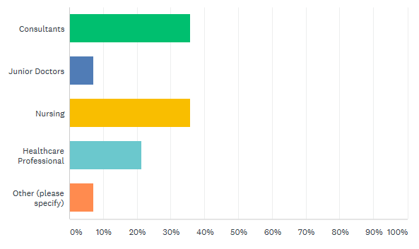

Role | Responses
Consultants | 5
Junior Doctors | 1
Nursing | 5
Healthcare Professional | 3
Other (Advanced Midwife/Nurse Practitioner) | 1

Method Used

The Questionnaire

The questionnaire was comprised of the following:

- Users were asked to rate (from strongly agree to strongly disagree) the following statements about the service:

- “I can trust the laboratory to provide results/reports when I need them”
- “I am satisfied with the quality of professional advice that I receive from the laboratory”
- “Professional advice is readily available from the laboratory when needed”
- “I am confident that urgent/unexpected results will be promptly communicated”
- “Local systems to transport specimens work well”
- “The level of out of hours service meets my needs”
- “Point of care testing is well supported by the laboratory”
- “I would recommend the laboratory service to a colleague”

- Users were asked to respond to the following questions:

- How might the Biochemistry service be improved?
- How might the Haematology and Blood Transfusion service be improved?
- How might the Specimen Transport service be improved?
- How might the Results Delivery service be improved?
- How might the provision of advice on test use and interpretation be improved?

- The closing statement to users asked for any other comments they wish to make about the service provided by Laboratory Medicine. (This was an optional question).

The laboratory target for user satisfaction is that for each statement a satisfactory response of > 90% must be achieved. We have defined a satisfactory response as either Strongly Agree, Agree, or Neither Agree nor Disagree. Any results falling outside of this limit will require further investigation to see what appropriate actions are required to improve that aspect of the service

Results

The following graphs illustrate the results of the responses for each of the statements:

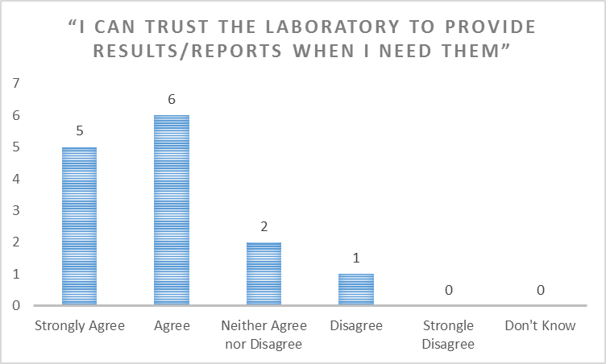

Answered: 14. Skipped: 0.

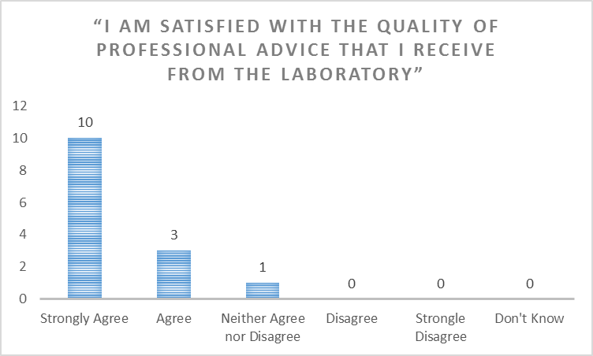

Answered: 14. Skipped: 0.

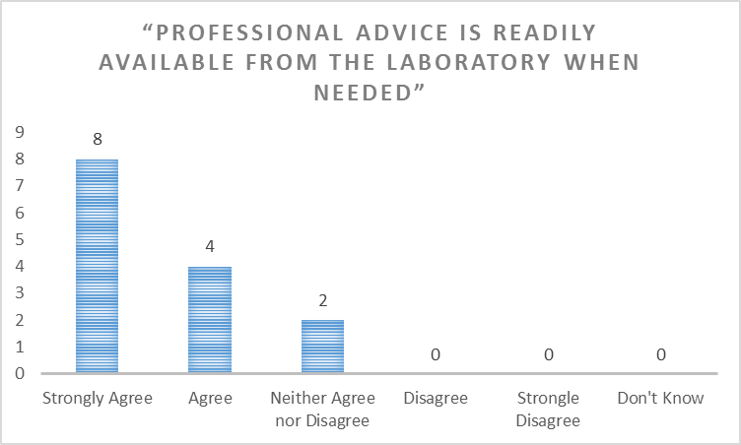

Answered: 14. Skipped: 0.

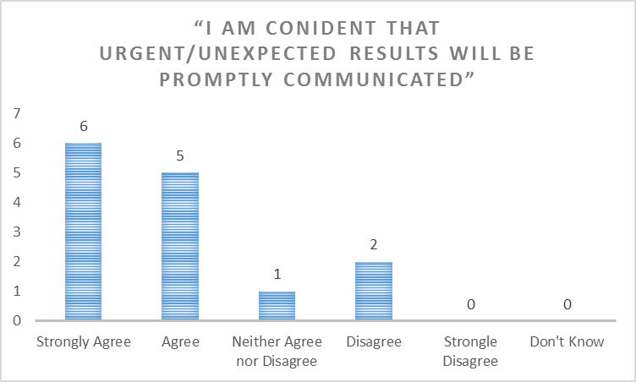

Answered: 14. Skipped: 0.

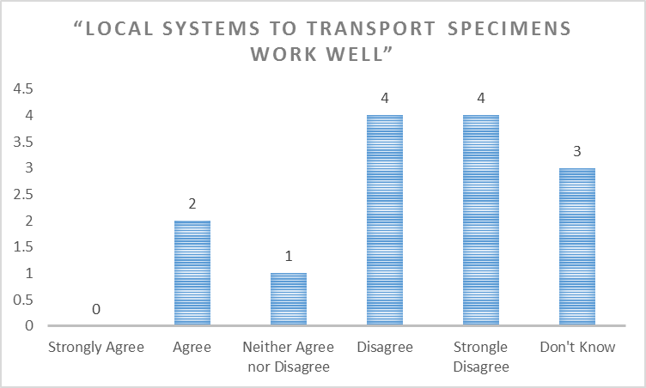

Answered: 14. Skipped: 0.

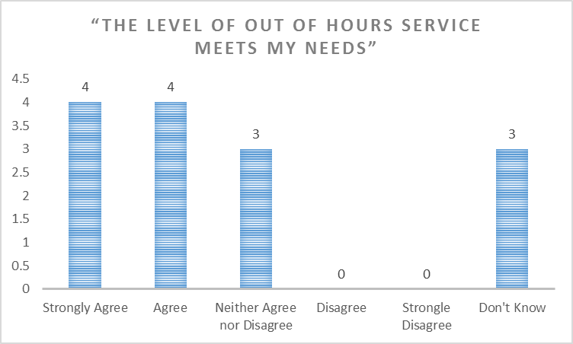

Answered: 14. Skipped: 0.

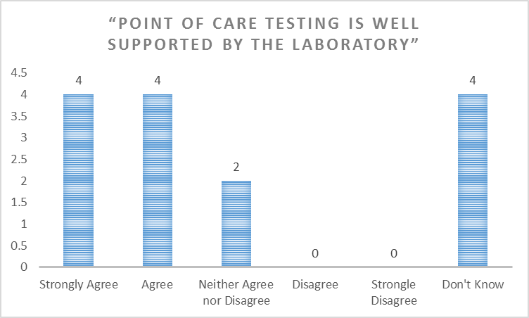

Answered: 14. Skipped: 0.

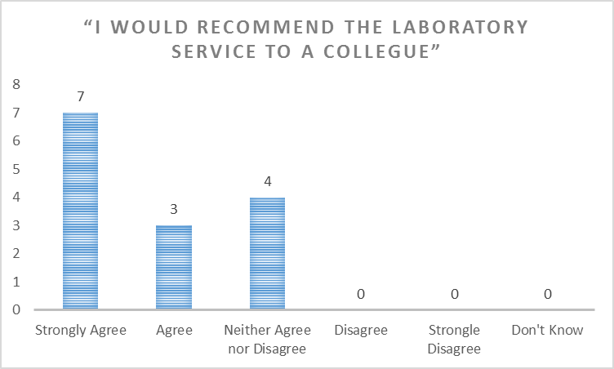

Answered: 14. Skipped: 0.

Summary Table of Percentage User Satisfaction

The laboratory target for user satisfaction is that for each statement a satisfactory response of > 90% must be achieved.

Statement | Percentage Satisfied (Strongly Agree to Neither Agree nor Disagree) | Percentage Dissatisfied  (Disagree to Strongly Disagree) | Don’t Know | Overall Percentage Satisfied (excluding “Don’t Know”)
“I can trust the laboratory to provide results/reports when I need them” | 78.57% | 7.14% | 0.0% | 78.57%
“I am satisfied with the quality of professional advice that I receive from the laboratory” | 100% | 0.0% | 0.0% | 100%
“Professional advice is readily available from the laboratory when needed” | 100% | 0.0% | 0.0% | 100%
“I am confident that urgent/unexpected results will be promptly communicated” | 85.71% | 14.29% | 0.0% | 85.71%
“Local systems to transport specimens work well” | 21.43% | 57.14% | 21.43% | 27.27%
“The level of out of hours service meets my needs” | 78.57% | 0.0% | 21.43% | 100%
“Point of care testing is well supported by the laboratory” | 71.43% | 0.0% | 28.57% | 100%
“I would recommend the laboratory service to a colleague” | 100% | 0.0% | 0.0% | 100%

Users responded to the questions as follows:

How might the Biochemistry service be improved?

6 Skipped.
8 Responses:
- Not sure if can as get a good service already
- Add some more paediatric neurology tests to ICE (antibodies to NMDAR, VGKC, MOG, AQP4, GAD)
- It would be useful to have permission for some other staff, such as ketogenic dietitians, to make requests for tests that are part of a standard protocol. Is it possible to get some of the rarer requests (not necessarily biochemistry, but HLA haplotype for narcolepsy susceptibility, for example) added as an electronic request also? The process for emailing the lab with add-on requests could be made simpler and clearer.
- There used to be a useful resource online that used to tell you what bottle, how much you needed for different samples. When different centres used, display result on ICE
- Improve POD/pneumatic tube system. I feel like it breaks frequently. - Prioritisation of TPN blood processing and reporting.
- Making sure there is a system to record and log the samples received. Some samples have been lost in the last year.
- More rapid turn around of tests sent out of the trust
- prompt reporting of urgent samples

How might the Haematology and Blood Transfusion service be improved?

9 Skipped.
5 Responses:
- Not sure if required
- n/a to me
- Not a user unable to comment
- They seem to be fast and efficient.
- Nothing

How might the Specimen Transport service be improved?

4 Skipped.
10 Responses:
- Some problems can occur with samples from Puzzlewood and sample delays and loss have occurred. This could occur at several points. Suggest the pathway be examined.
- PODS generally not working for long periods- days
- Sometimes it can take over 12 hours for the blood culture to be received in the lab which means that infants can need extra doses of antibiotics before the results are available.
- Reliable working POD system
- Some specimens seem to get misinterpreted at the transport stage: for example, tests for disorders of creatine synthesis and transport disorder treated as a creatinine level.
- n/a to me
- Porter coverage for urgent samples can be limited to such a large site
- Improve POD/pneumatic tube system
- The porters are quick and effective, but sometimes, when samples need to be transported to other hospitals, samples seem to get lost sometimes.
- Urgent samples...get lost in shute, taxis drop at lodge where samples stay, rather than going to lab asap

How might the Results Delivery service be improved?

7 Skipped.
- Responses:
- Default tick the box for ICEmail when test results complete
- More information available
- TPN blood reporting quicker
- Single ICE system for UHB, NBT and WAHT, primary and secondary care, without needing to use Open Net.
- Not sure.
- Highlighting of significant results to trust email account
- Our service happy to accept unvalidated results...this seems to be delay

How might the provision of advice on test use and interpretation be improved?

10 Skipped.
4 Responses:
- It would be useful to have a recommended 'best time' for contacting colleagues. At least we would feel less intrusive upon their working days.
- Easy to find information and next steps to be taken
- I think they are doing an outstanding job already
- We would like all bhcg and progesterone to be processed asap we need results before 4pm so management plan can be initiated delay until next day...a potential risk

Any other comments you wish to make about the service provided by Laboratory medicine?

9 Skipped.
5 Responses:
- The paediatric biochemical advice is an excellent service, always on hand and helpful with expertise
- I find that the service is excellent overall and I appreciate it greatly.
- useful if phlebs podded samples an estimation of the times it will take to get results
- Overall, I think they provide a very good service with a special mention to the specialist biochemist for metabolic who are so knowledge and helpful.
- You asked us to send separate samples for BHCG and progesterone this was done and results were much quicker, it seems to be a lot slower again. Also progesterone samples are not processed over the weekend, this would be really useful as it can avoid repeat visits for women (it is not used for an indicator of wellbeing in pregnancy...more an ectopic risk tool).

Laboratory Responses and Suggested Actions

How might the Biochemistry service be improved?

Comment | Laboratory Response/Action
Not sure if can as get a good service already | Thank you for this positive feedback
Add some more paediatric neurology tests to ICE (antibodies to NMDAR, VGKC, MOG, AQP4, GAD) | This will be added to the list of ICE changes and implemented in due course
It would be useful to have permission for some other staff, such as ketogenic dietitians, to make requests for tests that are part of a standard protocol. Is it possible to get some of the rarer requests (not necessarily biochemistry, but HLA haplotype for narcolepsy susceptibility, for example) added as an electronic request also? The process for emailing the lab with add-on requests could be made simpler and clearer. | Please contact us to discuss specific groups of clinical staff.  It is not possible to add all rare tests to ICE but please contact us about specific tests that you use frequently.  The ICE mail system is monitored regularly by reception staff. It is readily available for use. Please contact us to discuss any specific problems or suggestions.
There used to be a useful resource online that used to tell you what bottle, how much you needed for different samples. When different centres used, display result on ICE | This is already available as a link via the ‘Pathology Online Database’ link at the top of the Common Tests page. We will rename the link to make it more obvious.  All tests requested via UHB laboratory are displayed in ICE, and results from NBT, RUH and WAHT are available via the Open Net function.
Improve POD/pneumatic tube system. I feel like it breaks frequently. - Prioritisation of TPN blood processing and reporting. | The POD system is not run by Laboratory Medicine. Please address concerns to Estates.  TPN bloods could be prioritised if marked as Urgent.
Making sure there is a system to record and log the samples received. Some samples have been lost in the last year. | All biochemistry samples are logged as they pass through specimen reception.
More rapid turn around of tests sent out of the trust prompt reporting of urgent samples | We have streamlined the existing process this year and in future plan to implement electronic results transmission which will further speed this up.

How might the Haematology and Blood Transfusion service be improved?

Comment | Laboratory Response/Action
Not sure if required | N/A
n/a to me | N/A
Not a user unable to comment | N/A
They seem to be fast and efficient. | Thank you
Nothing | N/A

How might the Specimen Transport service be improved?

Comment | Laboratory Response/Action
Some problems can occur with samples from Puzzlewood and sample delays and loss have occurred. This could occur at several points. Suggest the pathway be examined. | We do not control the pathway for sample transport to the laboratory.
PODS generally not working for long periods- days | The POD system is not run by Laboratory Medicine. Please address concerns to Estates.
Sometimes it can take over 12 hours for the blood culture to be received in the lab which means that infants can need extra doses of antibiotics before the results are available. | Blood culture processing begins as soon as samples reach the lab. The process is outside our control prior to this point.
Reliable working POD system | The POD system is not run by Laboratory Medicine. Please address concerns to Estates.
Some specimens seem to get misinterpreted at the transport stage: for example, tests for disorders of creatine synthesis and transport disorder treated as a creatinine level. | Metabolic sendaway tests are handled by the specialist metabolic laboratory, which should minimise any such errors. Please continue to report any specific examples so that they can be fully investigated.
n/a to me | N/A
Porter coverage for urgent samples can be limited to such a large site | This is outside our control
Improve POD/pneumatic tube system | The POD system is not run by Laboratory Medicine. Please address concerns to Estates.
The porters are quick and effective, but sometimes, when samples need to be transported to other hospitals, samples seem to get lost sometimes. | Please report any such instances so that they can be fully investigated. Samples are outside our control after they have been handed over to the post or courier system.
Urgent samples...get lost in shute, taxis drop at lodge where samples stay, rather than going to lab asap | We do not control sample transport. Urgent samples must be delivered to specimen reception if they are to be processed rapidly.

How might the Results Delivery service be improved?

Comment | Laboratory Response/Action
Default tick the box for ICEmail when test results complete | Whilst sometimes appropriate it is not applicable to many tests/users, so it is not the default position
More information available | Please contact us with examples/suggestions
TPN blood reporting quicker | TPN bloods could be prioritised if marked as urgent.
Single ICE system for UHB, NBT and WAHT, primary and secondary care, without needing to use Open Net. | Unfortunately this is not consistent with Trust IT strategy
Not sure.
Highlighting of significant results to trust email account | ICE is not able to send messages to Trust e-mail addresses
Our service happy to accept unvalidated results...this seems to be delay | We can only issue results that have been fully validated

How might the provision of advice on test use and interpretation be improved?

Comment | Laboratory Response/Action
It would be useful to have a recommended 'best time' for contacting colleagues. At least we would feel less intrusive upon their working days. | Thank you. We have a duty biochemist rota and the duty biochemist is happy to receive calls at any time during the working day.
Easy to find information and next steps to be taken | We continue to review how this could be improved.
I think they are doing an outstanding job already | Thank you
We would like all bhcg and progesterone to be processed asap we need results before 4pm so management plan can be initiated delay until next day...a potential risk | bHCG is processed rapidly upon receipt. We are currently unable to offer the same service for progesterone but samples received in the morning should be reported by mid-afternoon. We will look into the possibility of expediting reports to your location.

Any other comments you wish to make about the service provided by Laboratory medicine?

Comment | Laboratory Response/Action
The paediatric biochemical advice is an excellent service, always on hand and helpful with expertise | Thank you. Provision of an expert specialist paediatric and metabolic service is a high priority for us.
I find that the service is excellent overall and I appreciate it greatly. | Thank you.
Useful if phlebs podded samples an estimation of the times it will take to get results | Please contact us to explain this in more detail
Overall, I think they provide a very good service with a special mention to the specialist biochemist for metabolic who are so knowledge and helpful. | Thank you. Provision of an expert specialist paediatric and metabolic service is a high priority for us.
You asked us to send separate samples for BHCG and progesterone this was done and results were much quicker, it seems to be a lot slower again. also progesterone samples are not processed over the weekend, this would be really useful as it can avoid repeat visits for women [ it is not used for an indicator of wellbeing in pregnancy...more an ectopic risk tool | There has not been a change in service levels, but as you indicate, progesterone is not routinely available at the weekend. This could be implemented – please contact us to discuss further.

Conclusion and Summary

The hospital user survey reflects the high quality service provided by the Clinical Biochemistry and Haematology laboratories at University Hospitals Bristol NHS Foundation Trust.

Using our target satisfaction criteria of >90% satisfactory response, it is clear that we continue to meet the needs of our users in the majority areas. One area highlighted for further investigation is Specimen Transport to see if this can be improved.

We appreciate the time taken by our users to complete the survey. We continue to seek other means of feedback where possible. We are continually reviewing the service we provide to our users and continually seeking to improve wherever possible, despite the growing financial challenge. We will take the feedback we have gained from this survey and use it to focus our efforts.

We are grateful to all those who took the time to respond to our User Survey and we hope that we will be able to address the issues you have raised so that filling in the questionnaire was time well spent. We will be repeating the Hospital User survey in 2020, to re-assess our performance and monitor any improvement.

If you want to feedback on the Action plan, or you did not get an opportunity to complete the User Survey and want to provide feedback regarding our services please contact our Quality Management Team, Carolyn Perry Carolyn.Perry@UHBristol.nhs.uk and Mark Nicholas Mark.Nicholas@UHBristol.nhs.uk who will be happy to respond to any feedback.

If you prefer please contact the head of service Elizabeth Worsam Elizabeth.worsam@UHBristol.nhs.uk

