# 

# WI_002 - Instructions and guidance for completion of Serious Adverse Event (SAE) forms

|  |
| --- |
| An event/reaction is serious if it:   * results in death, * is life threatening, * results in persistent or significant disability/incapacity, * requires hospitalisation, * prolongs a current hospitalisation * results in a congenital anomaly or birth defect. |

*This form must be used where University Hospitals Bristol and Weston NHS Foundation Trust (UHBW) or University of Bristol (UoB) is the sponsor of the research study in which the SAE has occurred, or where no other form has been provided by the sponsor.*

*The instructions below apply to studies which are sponsored by UHBW or UoB. If using UHBW’s SAE template for other sponsored studies, please send it directly to the sponsor and in accordance with their instructions.*

**Instructions for completion of Initial and Follow up Report Forms:**

1. Initial Report Form

As soon as possible, **and at the latest within 24 hours of becoming aware of event**:

* Complete the Initial Report Form and send to **UHBW** at: [research@uhbw.nhs.uk](mailto:research@uhbw.nhs.uk)

Please do not send the SAE initial or follow-up forms to an individual person’s account. This ensures that your report will be reviewed and actioned in a timely manner should the staff member be unavailable.

Please ensure that all sections have been completed as far as possible. Any forms that have been submitted to UHBW with missing information, including causality assessment and expectedness (as applicable) and PI/delegated individual sign off, must be re-submitted and signed **ASAP** (within at least 72 hours of the initial report).

Where UHBW is sponsor, initial and follow-up forms may only be submitted in electronic format. Forms should be submitted via email to [research@uhbw.nhs.uk](mailto:research@uhbw.nhs.uk).

The electronically submitted forms should include a scanned, written signature of the CI/PI/delegated individual. Alternatively, a typed or pasted image signature is acceptable, but only when sent from the CI/PI/delegated individual work email account as confirmation of signature. R&D require a copy of the original e-mail from the CI/PI/delegated individual with the signed SAE form attached.

2. Follow-up Report Form

**SUSARs**

If the event is on-going, then **within five days of UHBW becoming aware of the event** the site must complete the Follow up Report Form and send to **UHBW** at [research@uhbw.nhs.uk](mailto:research@uhbw.nhs.uk)

# Page 1 of 4

**Non-SUSARs**

If the event is on-going, then **within 10 days of UHBW becoming aware of the event** the site must complete the Follow up Report Form and send to **UHBW** at [research@uhbw.nhs.uk](mailto:research@uhbw.nhs.uk)

* Please ensure that all sections of the forms have been fully completed and for ease of review and continuity, please send follow-up form from the same email thread as the corresponding original SAE submission.
* Further Follow up Report Forms do not need to be completed within a specified timeframe unless the R&D department informs you that this is a requirement. They should only be submitted if there has been a significant change/update of the SAE. The forms should be reviewed and signed by the PI/delegated individual before submitting to the sponsor.

3. General instructions for completion and submission of reports

* For multi-centre studies where CI is not the investigator making this report, the main study team should send a copy of each form to the Chief Investigator.
* The main study team should send a copy of each form to other parties where applicable e.g. Data Safety Monitoring Committee.
* Original forms should be kept in the Investigator Site File (ISF).
* Identifiable information must not be sent to sponsor unless patient consent allows sponsor access, it is essential, and it is sent via a secure method.

**Definitions**

1. Onset date = date when an adverse event became defined as ‘serious’. *See SAE template Section 3 for definitions.*
2. ‘Date team became aware of the event’ = date that the local research team became aware that it was an SAE i.e. it refers to the clinical research team (not the co-ordinating centre) and when the event became upgraded from an AE to an SAE. *See SAE template Section 3*
3. End date = when the adverse event is no longer deemed to be serious. In most cases this is when the patient is discharged from hospital. *See SAE template Section 3*
4. Life threatening, in the definition of "serious", refers to an event in which the patient was at risk of death at the time of the event; it does not refer to an event which hypothetically might have caused death if it were more severe. Source*: ICH Clinical Safety Data Management: Definitions And Standards For Expedited Reporting E2a*. For example, an asthma attack could be life threatening but may not necessarily be life threatening for the particular reported event. *See SAE template Section 3*
5. ‘Resolved’ = SAE resolved.  For example, if a patient is discharged from hospital the event would no longer be an SAE and is therefore resolved even if, from a clinical perspective, they may still be receiving treatment (e.g. wound dressings applied by community nurse). If a patient has multiple SAEs at the same time and one of the SAEs has resolved, then even if the patient remains in hospital for another SAE, the resolved SAE should be recorded as resolved. *See SAE template Section 5*

Page 2 of 4

1. ‘Resolved with sequelae’ – this refers to an event where there will be an ongoing disability as a consequence of the SAE (e.g. a stroke).  In contrast, if a patient has an infection (the SAE) and is discharged from hospital with antibiotics and is still slightly unwell, this would be classified as ‘resolved’ because the condition is temporary and it is expected that there would be no long term disability as a result of the SAE. *See SAE template Section 5*

**Additional guidance on completing the forms**

1. All SAEs relating to CTIMPs and interventional surgery trials must be signed off by a CI/PI/delegated medically qualified individual.
2. The sponsor strongly recommends that the PI delegates other clinician/s (CTIMPs and surgery) or appropriately qualified individual/s to review SAEs to cover absences such as annual leave. This is necessary in order to comply with the timelines in these Work Instructions. (*see pg.4* )
3. All changes to the form must be counter-signed and dated  Therefore, even if an entry was made in error and was crossed through on the same day by the same person who made that error, that person must still counter-sign and date the change.
4. Any change to the SAE form which needs to be taken into consideration during the causality assessment (i.e. relatedness and expectedness) is deemed to be a substantive change and must be counter-signed and dated by the PI/delegated individual.  For example, if there was a change to the event name or significant additional information added to the form this would be considered a substantive change and would need to be re-assessed for causality.   Non-substantive changes can be countersigned and dated by the nurse.
5. It is permissible to provide multiple reasons in the SAE initial report form section 3 ‘SAE classification’.
6. Medical judgement should be exercised in deciding whether an AE/AR is serious. SAE/SARs that are not immediately life-threatening or do not result in death or hospitalisation but may jeopardise the subject or may require intervention to prevent one or the other outcomes listed in the definition above, should also be considered serious.
7. Multiple events should be reported on separate SAE forms for individual assessment against the RSI. Additionally, please do not send multiple SAE forms in batch in one email submission – please use a new email thread for each SAE, as this helps with traceability of review and clear record keeping.
8. Please avoid using abbreviations in the SAE report.

Page 3 of 4

**SAE/SUSAR Reporting Timelines to Sponsor**

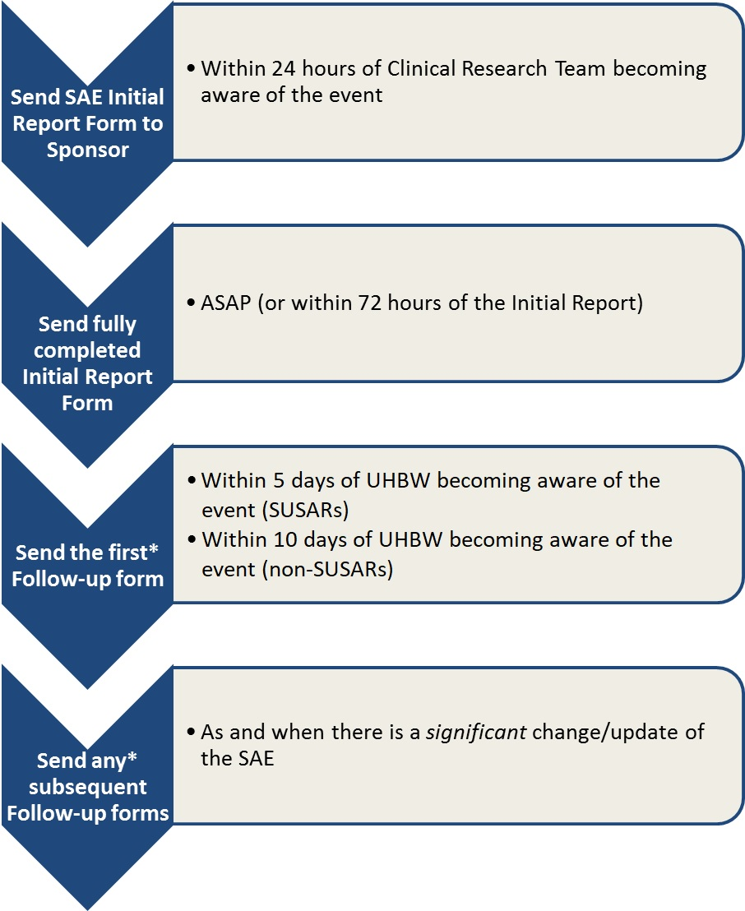

**\* If applicable**