Stroke Prevention and Atrial Fibrillation Key Facts
Prevalence
- Prevalence in all ages should be around 1.3% Over 65yrs > 4% Over 75yrs > 10%
- AF1 (Atrial Fibrillation) QOF register will include those patients coded for Atrial Flutter, and these should be included as part of any medication/anticoagulation review process
- AFL (Atrial Flutter) - if a patient presents with new onset AFL, refer to secondary care and if the decision is made to rate control, anticoagulate as for AF.

  CHADS₂ Scoring System
  A CHADS₂ score of 2 or more indicates the patient has a High Stroke Risk and could benefit from Warfarin. |  | Points
  C | Chronic Heart Failure | 1
  H | History of Hypertension | 1
  A | Age>75 | 1
  D  Anticoagulation; If a patient has a CHADS₂ score of 2 or more and is deemed suitable for warfarin, refer to local anticoagulation service either practice or acute trust based for initiation as per local protocols. | Diabetes Mellitus | 1
  S₂ | previous Stroke or TIA | 2
  CHA₂DS₂-VASc Scoring System
  - NICE estimate that approximately 40% of patients in whom warfarin is indicated are not receiving it.
  - Aspirin represents a 22% reduced stroke risk
  - Warfarin represents a 64% stroke risk
   |  | Points
  C | Chronic Heart Failure | 1
  H  14% of all strokes nationally are attributable to AF. The cost of an acute stroke (acute care) is approx £12,000. The cost of anticoagulation per person per year is £382.90 (NICE CG 36, 2006) including the cost of monitoring. | History of Hypertension | 1
  A₂ | Age>75 | 2
  D | Diabetes Mellitus | 1
  S₂ | previous Stroke, TIA or TE | 2
  V | Vascular disease | 1
  A  The safety of warfarin has been shown in the BAFTA (Birmingham AF trial in the aged) study. In comparison to Aspirin, warfarin has similar bleeding risk and is actually safer in the older (>80 yrs) age group. | Age between 65 and 74 years | 1
  Sc | Sex category (female) | 1
BAFTA trial, The Lancet 2007; 370: 493 – 50 Contra-indications
Absolute Relative
History of intra-cranial haemorrhage History of GI/HU haemorrhage
Major non-traumatic haemorrhage in last 5 yrs History of endoscopically/radiologically proven peptic ulcer
Oesophageal varices Unexplained anaemia
Previous hypersensitivity/adverse reaction to warfarin Clotting disorders
Advanced malignancy/terminal illness Combined aspirin and clopidogrel therapy
BP180/110 (reconsider when controlled) Alcohol abuse
Pregnancy Non-compliance; impaired cognitive function/psychiatric problems
Risk of falls (investigated)
Renal/hepatic impairment
Drug interaction

Age should not be considered as a contra-indication to warfarin

No AF  Stroke/TIA  Aspirin 300mg for 14 days, then 75mg daily then Clopidogrel for life. | AF plus  Stroke/TIA  Warfarin unless contraindicated. If contraindicated, treat as for stroke.

Antiplatelet drugs are effective against platelet rich clots which tend to form in arteries. They work by preventing platelet aggregation (clumping). Anticoagulants prevent clot formation in arteries and veins by interrupting the clotting cascade. In AF, embolisation of clots in the left atria is the main cause of strokes. Anticoagulants prevent these, but as platelets are not abundant, antiplatelet agents have little role in this process.

- Patient with severe CKD (eGFR of less than 30) are at high risk of haemorrhage and therefore not routinely recommended to be prescribed Warfarin. At this level of renal impairment, should there be a compelling reason to consider warfarin, a renal specialist should be consulted. Caution should also be taken for patients with severe liver disease
- In line with the NICE AF guideline, Warfarin should be continued 4 weeks post cardioversion and if the patient has a CHADS₂ Score of 2 or more e.g. underlying disease they should stay on warfarin for life
- There is no place for use of aspirin and clopidogrel together - to be discussed
- Stroke/TIA patients require clopidogrel monotherapy (aspirin allergy)

Risk of falling
The risk of intracranial haemorrhage on warfarn occurring as a consequence of a fall is, as some studies have suggested, much lower than most people believe and should not be factored into the decision.

Ref – Man-Son-Hing et al. Archives of International Medicine. 1999; vol. 159 (7) pp. 677-85
Patient Decision Aids (PDA) can be extremely useful when talking to patients about risks versus benefits of different treatments and medications. Download it from: http://www.npci.org.uk/therapeutics/cardio/atrial

For high risk patients taking aspirin
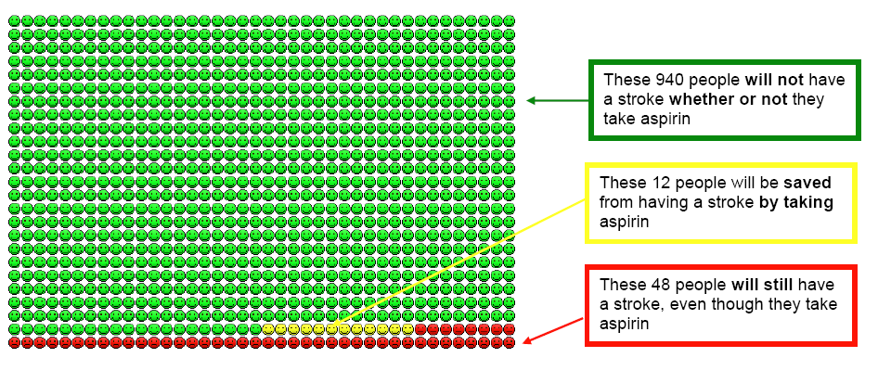
For high risk patients taking warfarin
Risk of falling (with possible increase in chance of subdural haematoma) should not influence the choice of warfarin.

Older patients taking warfarin must fall about 295 times in one year for warfarin not to be optimal therapy and the propensity to fall is not a contraindication to the use of antithrombotic agents (especially warfarin) in elderly persons with AF.

Ref – Man-Son-Hing et alArch Intern Med. 1999; 159(7):677-85
Patient Decision Aids (PDA) can be extremely useful when talking to patients about risks versus benefits of different treatments and medications. Download it from: http://www.npci.org.uk/therapeutics/cardio/atrial

